SUBCOURSE EDITION
FI 0950 A

MANAGEMENT SURVEY

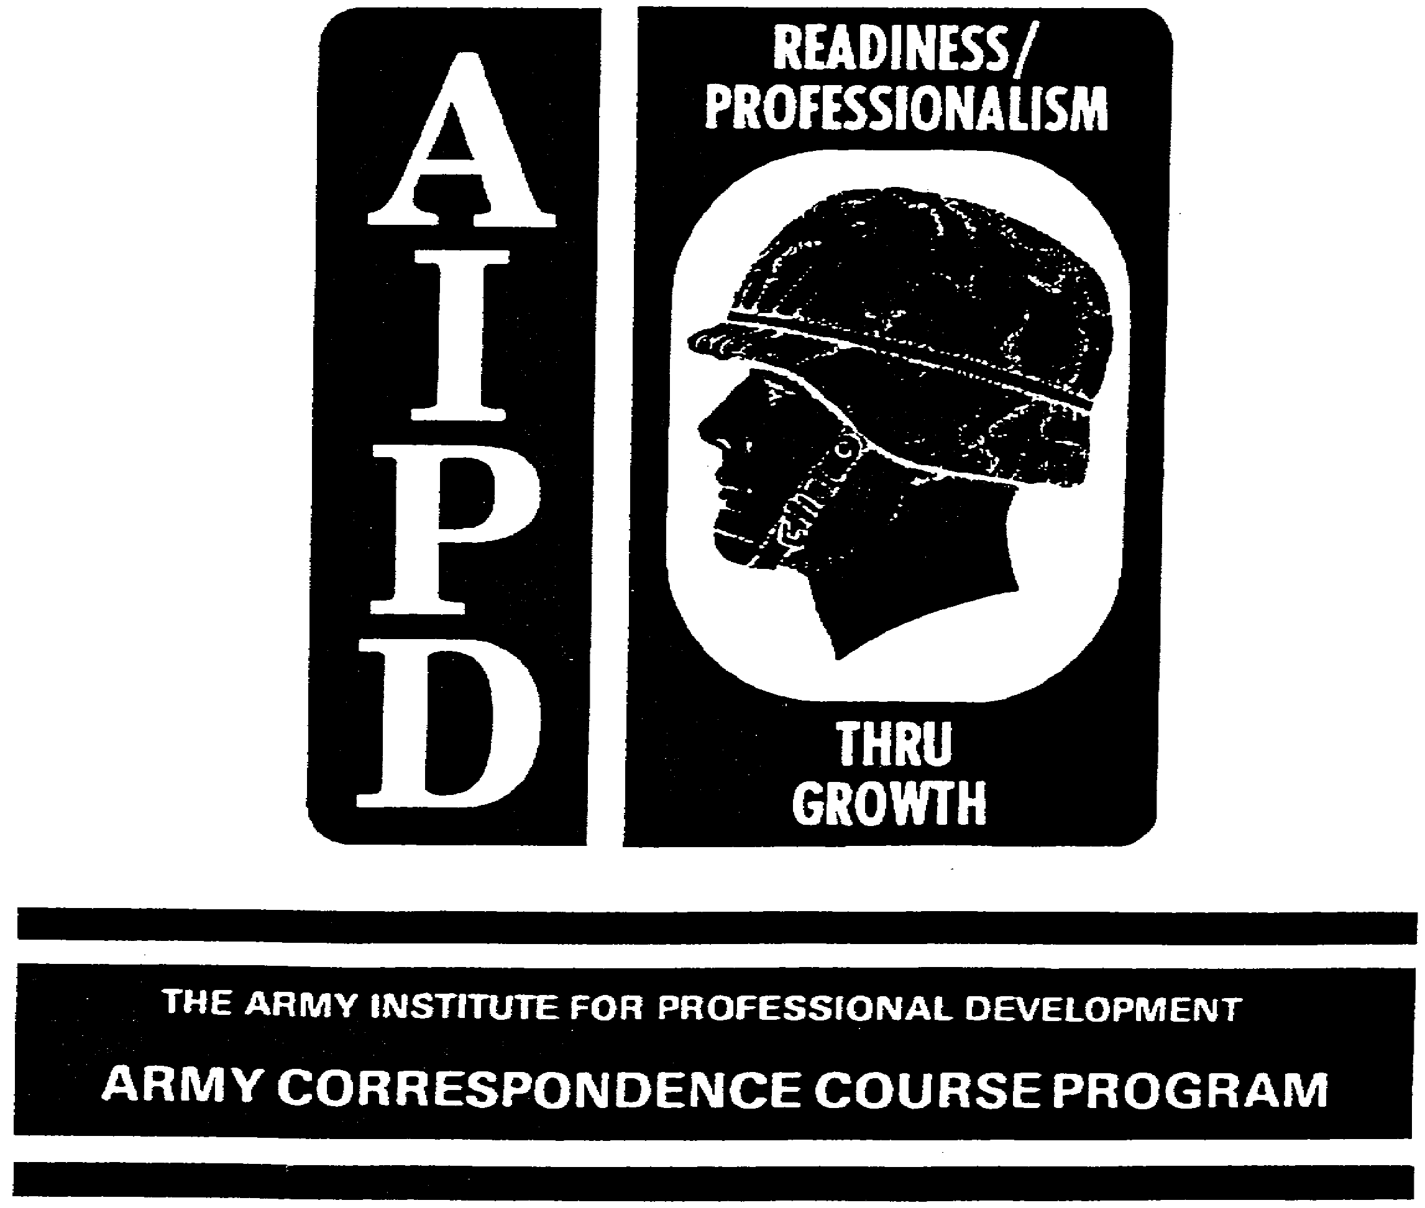

MANAGEMENT SURVEY

Subcourse Number FI 0950

Edition A
May 1991

United States Soldier Support Institute

4 Credit Hours

SUBCOURSE OVERVIEW

This subcourse will teach you the basic procedures involved with conducting a management survey while using management survey techniques and Management Information Systems.

Terminal Learning Objective

Actions: You will define the primary purpose of a management survey, review problem identification and analysis, examine the conduct of the management survey, and name the management survey techniques.

Conditions: You will have access to extracts from DA Pam 5-4-1, and to this subcourse.

Standards: You will identify management survey techniques in accordance with (IAW) this subcourse and DA Pam 5-4-1.

There are no prerequisites for this subcourse.

The following publication is the reference for this subcourse:

DA Pam 5-4-1 Management Survey Handbook, 20 July 1973.

This subcourse contains information that was current at the time it was prepared. In your work situation, always refer to the latest publications.

The words "he," "him," "his," and "men," when used in this publication, represent both the masculine and feminine genders unless otherwise stated.

i FI 0950
TABLE OF CONTENTS

Section Page

Subcourse Overview

Lesson: Management Survey 1

Part A: Purpose of a Management Survey 2

Part B: Preparing and Conducting a Survey. . 3

Part C: Combining Management and Manpower
Surveys 31

Part D: Closeout Procedures and Briefings. . 32

Part E: Preparation of the Written Report. . 35

Practice Exercise 37

Answer Key and Feedback 40

Appendix: Extract from DA Pam 5-4-1 46

ii FI 0950
LESSON

MANAGEMENT SURVEY

LEARNING OBJECTIVE

Actions: You will define the primary purpose of a management survey, review problem identification and analysis, describe conducting a survey, and name management survey techniques.

Conditions: You will be given access to extracts from DA Pam 5-4-1, and this lesson.

Standards: Your identification will be in accordance With the instructions in this lesson and excerpts from DA Pam 5-4-1.

INTRODUCTION

1. The Director of Resource Management (DRM) has a continuing obligation to his commander, the major activity directors, and the heads of operating elements to appraise the effectiveness of operations and suggest and develop solutions to management problems. This is the objective of management analysis and the primary responsibility of the Management Analysis Division. The DRM satisfies the commander's desire to know how well each part of the overall job is done. He helps the operating chiefs by providing objectives and skilled aid in answering their natural question, "How am I doing?" He resolves or offers alternate solutions to problems that the operating chief has neither the time, the perspective, nor the special analytical skills required for solving. The more important the problems the DRM helps resolve, the more effective is his performance.

2. The skills the DRM's staff uses in resolving these key problems constitutes "management analysis." The Army defines management analysis as a staff function undertaken to help a commander, his staff, and supervisors in the chain of command, find and install better, faster, or cheaper ways to carry out their missions. It consists basically of applying scientific principles and techniques to management problems and working relationships. Management analysis, by its very nature, is a cooperative undertaking. The effective management analyst obtains results by working closely with the persons directly responsible, thus getting a combination of the operator's first-hand knowledge of his problems with the management analyst's special skills, experience, objectivity, and time.

1 FI 0950
3. The management analyst uses various techniques for gathering facts, analyzing them, and developing solutions. The most commonly used techniques or tools developed by Government and industry over many years are:

Time and Motion Studies Systems and Procedures Analysis
Work Measurement Space and Layout Studies
Operations Research Manpower Surveys
Organization Analysis Management Surveys

4. The extent to which these techniques are used depends upon the mission of the command, commander's desires, and nature of existing management problems.

5. The goal of management analysis is improvement of the methods by which missions are accomplished, to the end that resources are used in the most economical, efficient, and effective manner. The management analysis service provides objective methods for appraising or measuring performance, and for helping to improve that performance. This service endeavors to incorporate improved practices in the management systems, operations, and activities of a command through advice, guidance, and assistance to the commander, staff, and operating personnel.

PART A - PURPOSE OF A MANAGEMENT SURVEY

1. A management survey is a study that is intended to show managers of surveyed activities better ways to carry out their missions. It provides the commander with the organizational structure, procedures, and techniques he can employ to accomplish his mission in the most economical, efficient, and effective manner possible. Management surveying is an art, not a science. It requires a lot of common-sense, some imagination, a degree of inquisitiveness, a fair amount of hard work, some prior training or experience, a few handy tools or techniques, and a lot of diplomacy.

2. When a survey is requested, the requestor usually specifies what he wants the team do or look at. If he does not specify, only the time available, the team size, composition, experience, and ability, and the nature of the surveyed organization limit what the team should do.

2 FI 0950

3. When a survey is directed, the director (usually the Chief of Staff) will normally specify the limits of the survey. However, on rare occasions the Major Army Command (MACOM) Deputy Chief of Staff for Resource Management (DCSRM) will be directed to look at the manpower aspects of an organization, even though this is normally a United States Army Force Integration and Support Agency (USAFISA) responsibility.

4. Often, the MACOM DCSRM will conduct a management survey in conjunction with a manpower survey by USAFISA. This can be done as either a combined team or as separate operations in which the management survey is followed by the manpower survey. USAFISA will provide the organization being surveyed with pertinent comments concerning manpower utilization based upon findings and recommendations of the management study.

PART B - PREPARING AND CONDUCTING A SURVEY

1. The steps you use in preparing for a survey are:

a. Step 1. Establish a point of contact in the surveyed organization. This can normally be done in a brief memorandum, which advises the organization regarding the survey team composition, the length of the survey, the entrance and exit interview requirements, a milestone schedule, particulars concerning the briefings, and written reports prepared by the survey team. All of these items cannot always be covered in the initial memorandum, but as many as possible should be. These items will be discussed in detail later on in the lesson. A sample memorandum is shown in figure 1-1.

b. Step 2. Get copies of pertinent mission and function statements; organizational charts; special studies or proposals affecting organization, missions, or functions; the most recent manpower surveys when appropriate; and relevant DA publications relating to organization, missions, and functions.

c. Step 3. Determine as early as possible if organizations other than the one being surveyed must be considered in the study. Many times there are missions and functions that overlap with higher, lower, or adjacent organizations. This point can be critical in determining the length of the survey, as well as the team composition.

d. Step 4. After a review of these items, calculate the length of time required for the survey. Do not forget to add the additional time needed to prepare briefings and written reports, to the time required for the actual onsite survey. Figure 1-2 is a sample computation worksheet.

3 FI 0950

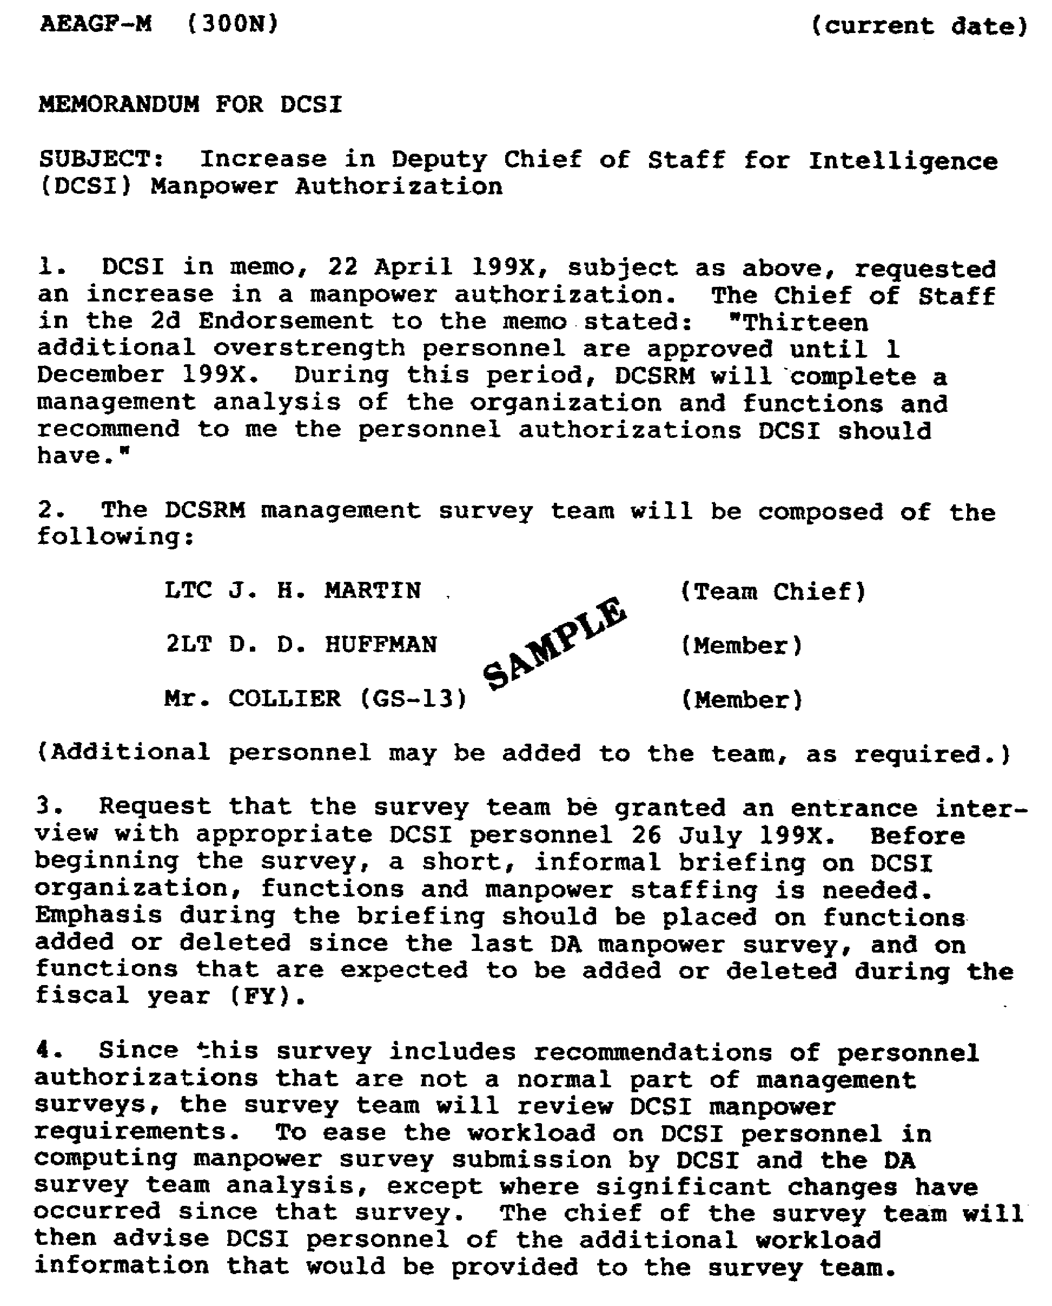

Figure 1-1. Sample Memorandum to Announce a Survey

4 FI 0950

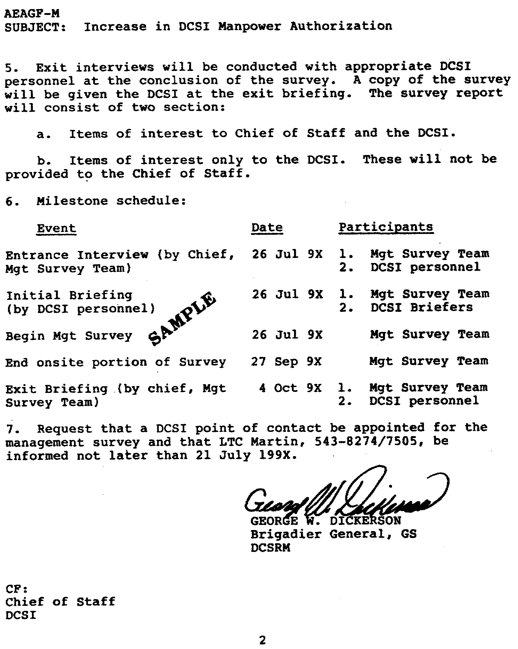

Figure 1-1. Continued.

5 FI 0950
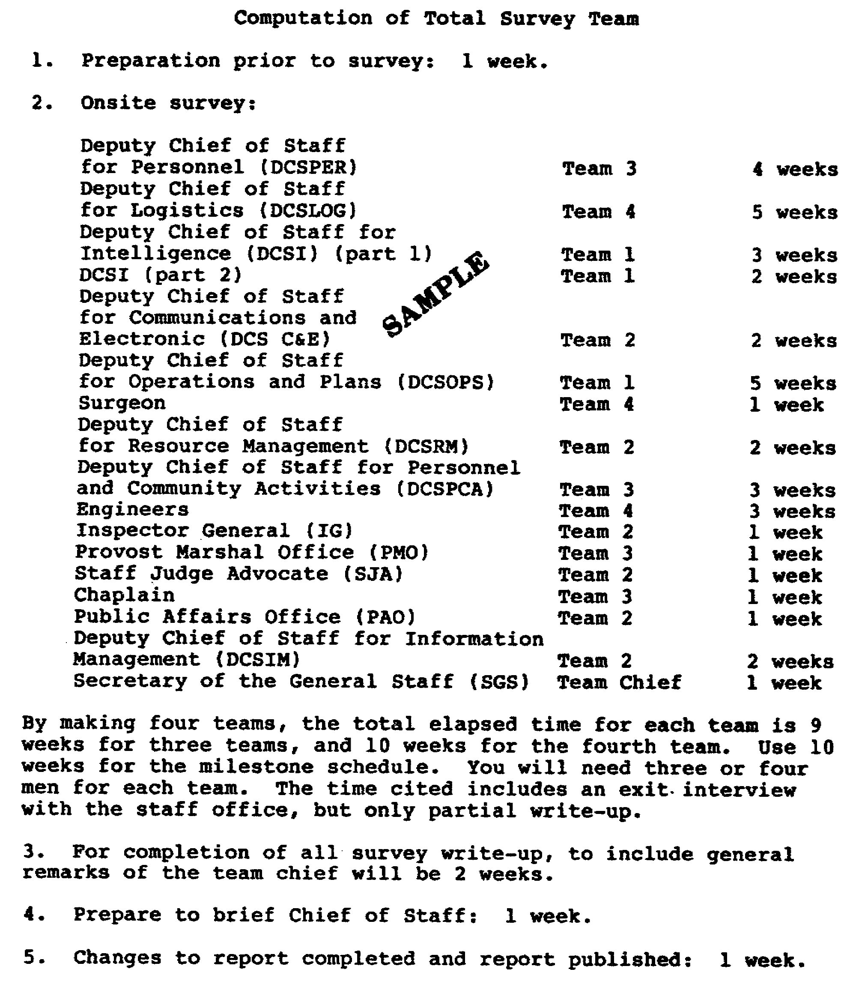

Figure 1-2. Computation Worksheet

6 FI 0950

e. Step 5. Determine how many surveyors are required to do the job. This often becomes a "crunch" point. This is where you must balance people available with time available. Match your surveyors' skills to the areas to be surveyed, as much as possible.

f. Step 6. develop a rough milestone schedule for the study. The schedule should normally show the (1) entrance interview and initial briefing by the organization being surveyed, (2) estimated length of the onsite portion of the survey, (3) exit interview, and (4) presentation of the written report to the surveyed organization. Figure 1-3 is a sample of a milestone schedule.

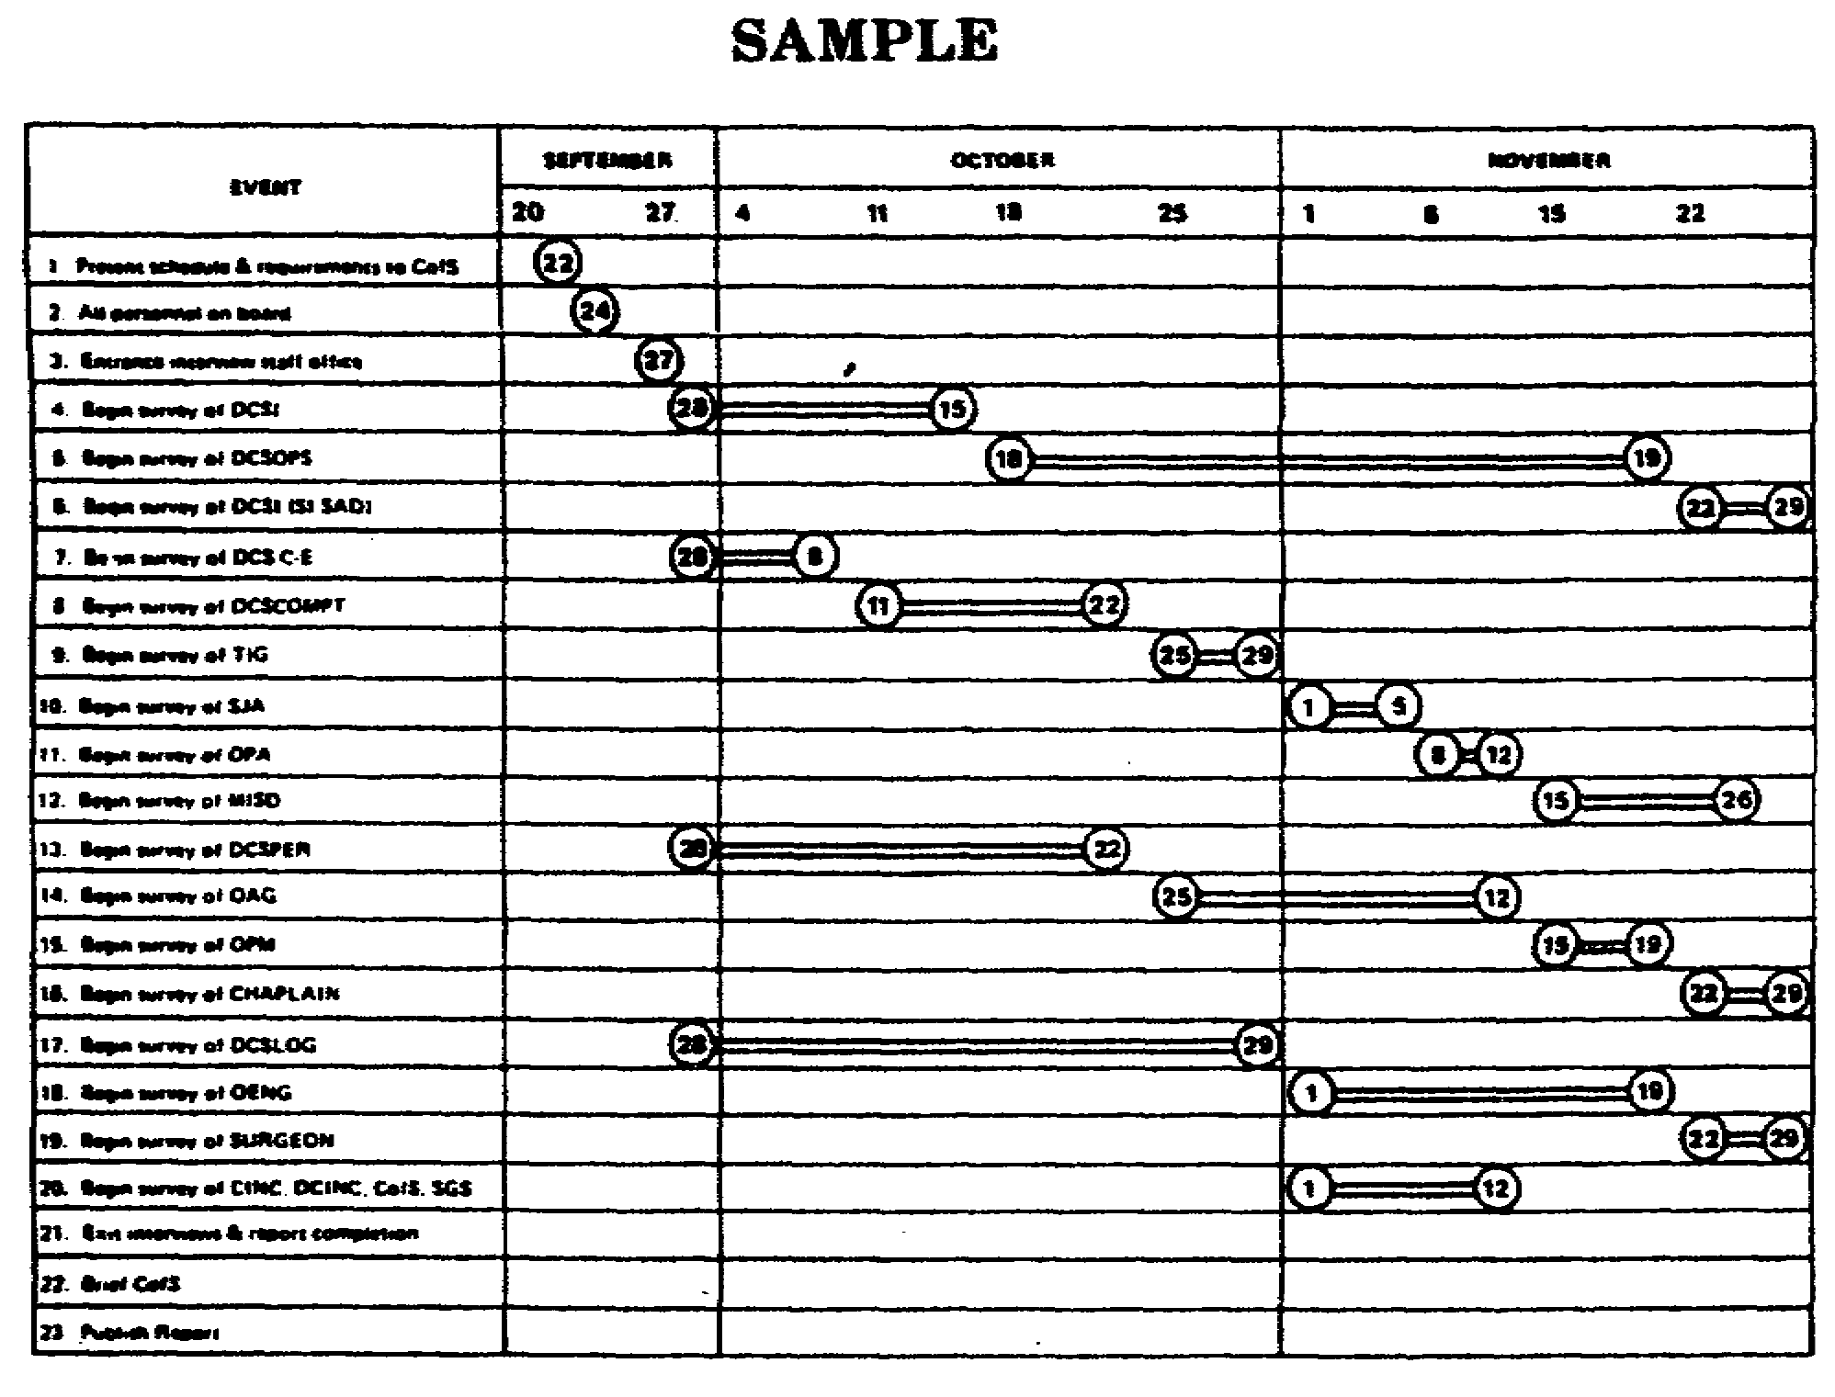

Figure 1-3. Milestone Schedule

7 FI 0950
g. Step 7. Determine the type of exit briefing you intend to give: elaborate or simple. Of course, you must realize that your initial idea may change once you get deeply into a survey. Remember that a survey seldom ever works out the way you expect.

h. Step 8. Decide on the type of written study report that you will prepare. The type of format and the type of detail in the report will have a major impact on how you conduct the survey. You can write up a fancy report with a lot of useful and useless enclosures, or you can write a simple, straight forward report that has only the bare essentials. Use the simple approach. Your report should contain those things that you think the commander should read and/or those things that tell an operator how to do his job better.

Note: An example of what should be included in a study report is shown in figure 1-4. This will also be discussed later on in the lesson. Whether you make your report fancy or simple, above all, make it factual and accurate.

i. Step 9. Review the pertinent documents that you have obtained about the organization to be surveyed. These organization and function statements, manpower surveys, organization charts, special studies, and DA publications can give you a good insight into the organization. They also are invaluable during the course of the survey.

8 FI 0950

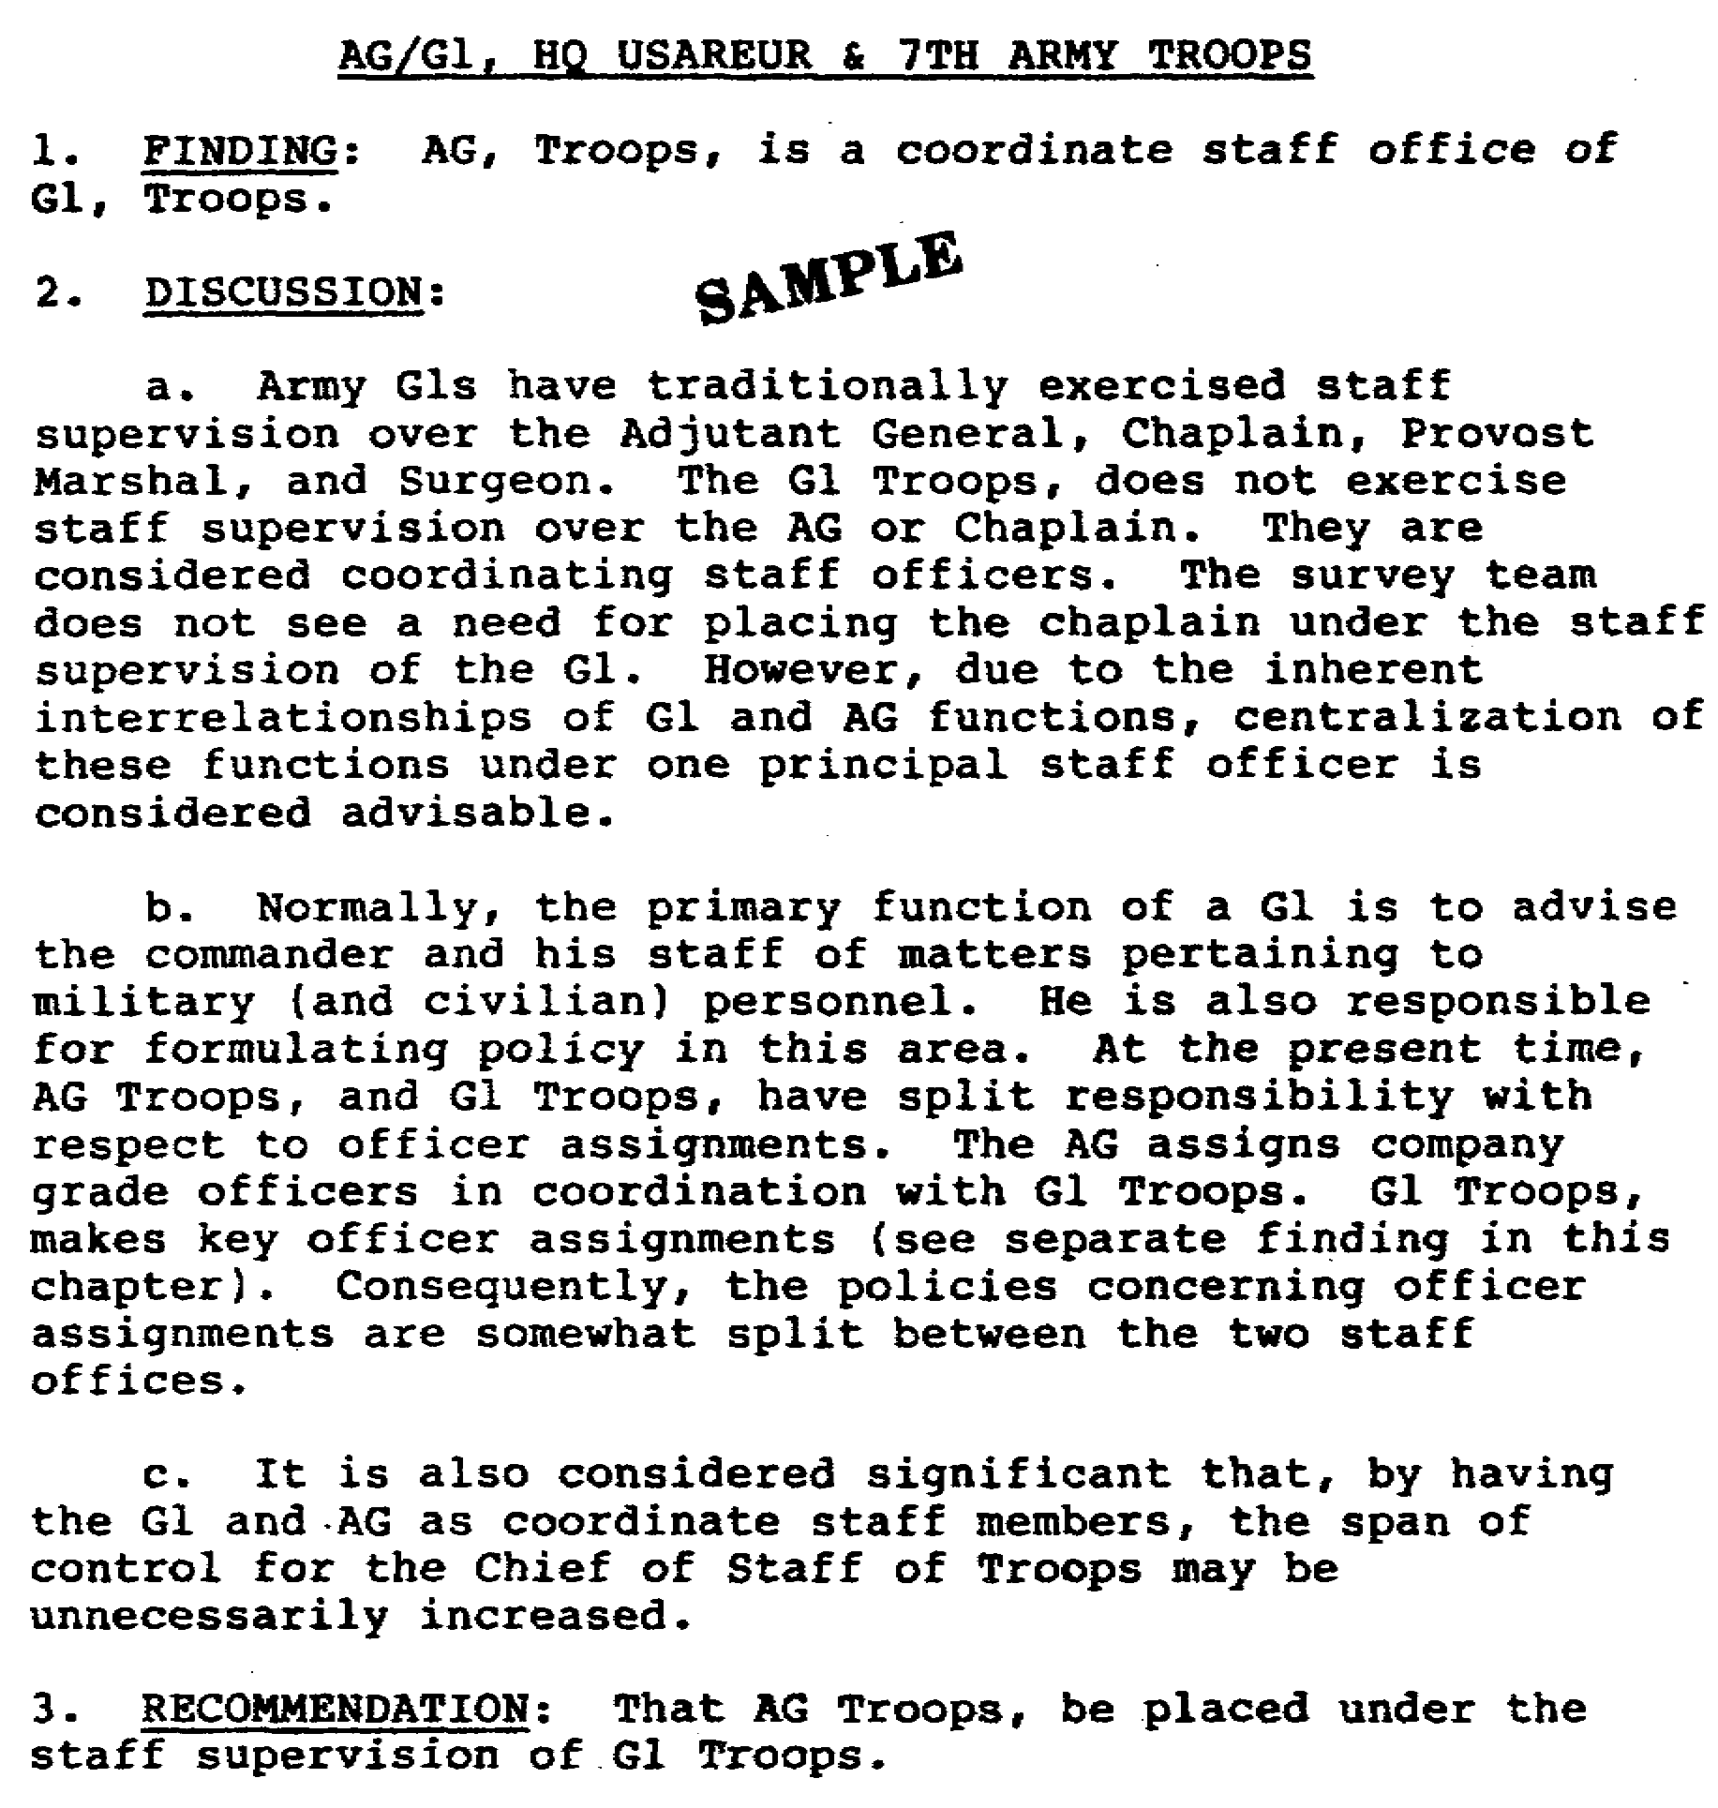

Figure 1-4. Content of a Written Study Report.

9 FI 0950

2. The survey is initiated with a "team entrance briefing." At the entrance briefing (which the team chief usually conducts), a brief but clear and complete description is given of the team's approach to the survey. Survey techniques can be discussed. Closeout procedures with various levels of supervisors should be mentioned. Requirements for team support (if not previously covered with the point of contact) should be detailed. The team members must be introduced. The tentative schedule for the survey can be covered, with emphasis on the length of time onsite, along with the dates and time of the exit briefings, and a date for the submission of the final written report. The senior officer present from the surveyed organization must understand all of these points. He must be given an opportunity to comment whenever appropriate.

3. Surveyed organization briefing.

a. The organization to be surveyed should present the following:

(1) How the organization functions. Throughout the survey, the single most important thing that the survey team must understand is the functional relationships of the 'blocks' on the organization charts.

(2) Reorganizations proposed, being considered, approved, or being implemented. You seldom find an organization that has not been involved in one of the four stages of reorganization.

(3) Realignments of functions proposed, being considered, approved, or being implemented within the organization.

(4) Pertinent comments about, or from, the most recent manpower survey. These often have good explanations of organizational and functional matters. Many times, they contain "gems" that can greatly aid the management survey.

(5) A reference to, and pertinent comments about, any special in-house or outside studies about the organization that could have an impact on the survey.

b. The survey team should -

(1) Ask for clarification of any point that is not clear.

(2) Consider readjustments to the survey schedule, survey approach, sequence of organizational elements to be surveyed, or the reassignment of surveyors to specific areas.

10 FI 0950

(3) Request pertinent surveys, studies, proposals, directives, etc.

(4) Understand the organization's stated mission and how the organization functions in relation to higher authorities and subordinate activities. Try to determine if the organization functions as per written charter or, as it has evolved, to suit the personalities of the people in charge over the years.

(5) Probe, diplomatically, for flaws in their reasoning with respect to both organization and functions.

(6) If not presented, find out where the document is that assigns the mission to the organization. This document is critical since mission statements are often misunderstood, too vague, or too broadly worded to justify specific missions. Over time, mission statements are often twisted or expanded to include things not originally intended.

(7) Get a feel for not only who the designated key people are, but also for where the real power lies (formal versus the always-present informal organization).

(8) Keep ever alert for potential trouble spots that may delay, divert, or even "sink' a survey. (These are usually missions, functions, or key people.)

c. Team meeting before beginning survey. This is your last chance to clean up problems before the survey begins, so use it.

(1) Clarify team member questions, and discuss potential problems.

(2) Make final adjustments in the team approach to the survey and to surveyor assignments to areas.

(3) Distribute appropriate documents to team members. Assign the jobs of locating other documents that you may need.

(4) Schedule, or prepare a standing operating procedure (SOP) for all team meetings.

11 FI 0950

d. Information Requirements and Fact-Finding Methods.

(1) Fact-finding is not an end in itself. It is directed toward the definition of existing conditions, the determination of cases, and the provision of the survey data base.

(2) The analyst, as previously described, gathers facts at the regulatory, the managerial, and the performance (worker) levels. On each of the specific subdivisions of the survey, he seeks the facts that will correctly answer appropriate questions beginning with "what," "why," "when," "where," "who," "how," "how much," and "how well." Frequently, the analyst approaches this search by developing lists of key questions, or "key lists," to ensure that he covers all important aspects of the problem. These lists enable him to see the problem as a whole, to visualize the scope and types of data needed, and to concentrate on the collection of essential information.

(3) There are two basic sources of information: existing documents and personnel. The two sources are complementary and both should be employed in every possible case. Information is usually extracted from these sources by one or more of the following general methods.

(a) Studying existing records.

(b) Personal interviews.

(c) Personal observations.

(d) Questionnaires.

(e) Statistical methods.

The selection of the methods you use will be dependent on the time involved and on an understanding of the basic limitations and advantages of each technique.

e. Study of Existing Records. The study of existing records is one of the essential steps in the management survey. The primary considerations in reviewing record are: how many records should be reviewed before turning to other fact-finding methods; and, how much reliability can be associated with the facts as found in existing records. There are two different schools of thought on this matter.

(1) According to one view point, analysts should review the existing records as the first step of a survey in order to:

12 FI 0950

(a) Gain an additional understanding of the organization's mission, its intended structure, procedures, and the like.

(b) Learn something of the manner in which the organization operates.

(c) Learn enough about the organization to ask intelligent questions and to be well informed for exploring problems with operating officials.

(d) Improve their chances of being accepted as competent and trustworthy. (If the organization's personnel recognize that the analysts are interested in the organization and want to understand its problems, they are usually much more willing to give them wholehearted cooperation than if the analysts appeared uninformed or uninterested). Many persons take pride in reviewing their activities with analysts whom they believe to be professionally qualified and interested.

(2) According to a second view point however, analysts should delay the study of existing records until they have obtained information from the organization's personnel. This is because:

(a) Material in the records is often out of date, so the study may be wasteful and misleading if records are reviewed first.

(b) The analyst who studies the records first may believe that he has found the answers to the problems and not engage in necessary, further study. Also, when he conducts interviews, he may not be an unbiased listener.

(c) Less time is needed to use the records to verify data received from other sources than to make an exhaustive record study the first fact-finding step. This is especially true when the analyst finds he must refer to the records again to verify some points.

(3) The analyst's timing of when he will make his study of existing records is usually less important than his obtaining correct and essential facts from them. He needs to select good cross-sections of materials that bring to light as much relevant information as possible. Some documents may be studied at the beginning of his fact-finding and others later, depending on the nature of the survey.

13 FI 0950

(4) The analyst's interest and emphasis may shift as he finds new possibilities for improvement. When this happens he should change his plans accordingly, while also staying within the framework of the survey objectives and overall plan.

f. Personal Interviews. In management surveys, the interview is one of the principle methods for collecting facts about the way a job is being done. A more subtle, but equally important aspect of an interview is the opportunity it provides for the interviewer to sell the idea of progressive improvement in operations, and to sow the seeds of acceptance for possible future change. These objectives are realized by providing the interviewee with a perspective of his activity in relation to the total problem area, and getting him to identify with the solution through the involvement of his suggestions and ideas.

g. Personal Observation.

(1) Basic. Personal observations are required in time and motion studies, layout studies, or in tracing the flow of work or documents. When such studies are necessary, they cannot be made unless the analyst obtains data by following and recording the action in detail.

(2) Supplemental. In the supplemental type of observation, the analyst observes the organization and nature of the situation as he moves about to look at records and conduct interviews. These types of observations are frequently made during the feasibility study, when the analyst is taking his "general tour' through the organization. The "general tour" is good for obtaining impressions, but is not good for obtaining facts upon which the final survey results will depend. However, an experienced analyst can use the "general tour" very effectively to determine where he should concentrate his efforts. The analyst seeks clues that assist him to:

(a) Identify persons who appear to be centers of activity, information, or influence.

(b) Find processes, working relationships, and physical arrangements that may be particularly in need of improvements.

(c) Find minor deficiencies that may be symptoms of important problems.

(d) Improve understanding of data obtained by other methods.

(e) Support recommendations, when necessary, with data he has gathered.

14 FI 0950

h. Questionnaires. Questionnaires used in management surveys usually are not standard forms, but are a type of data gathering sheet developed to fit a particular situation. Their use is usually limited by two related factors: questionnaires to obtain complex data are difficult to prepare; and replies to questionnaires are apt to be unsatisfactory unless both their preparation and their presentation to respondents have been extremely well planned and executed.

j. Statistics. While the use of statistics is primarily considered as an analysis technique, statistical sampling techniques have also wide application in the fact-finding phase of the management survey.

(1) Work Sampling. A work sampling studies consist of a number of observations, taken at random interval, of the state or condition of an object of study. These observations are then recorded and classified into predefined categories pertinent to the situation. Based upon the percentages of the total sample observations taken in each category, inferences are drawn about the relative frequencies or appearance of events in each of the categories.

(2) In its simplest form, work sampling consist of making observations, at random intervals, of a department or a group of workers or machines and noting whether they are working or idle. The percentage of the day that the worker is idle is the ratio of the number of idle tally marks to the total number of tally marks.

(3) The underlying theory of working sampling is that the percent of occurrence of a condition as found in a random sample reflects to a known degree of accuracy the percent of the condition in the total activity. The degree of accuracy can be regulated by varying the number of observations. With work sampling it is possible to evaluate the degree of reliability of the information in a study at any point in the study, and goals can be adjusted as new information is gathered or as limitations dictate.

(4) Advantages of Work Sampling. Work sampling offers many advantages over conventional personal observation or work measurement techniques.

(a) It can be tailor-made to gather information on anything that can be observed.

(b) It provides data economically and on a timely basis.

15 FI 0950

(c) Survey analysts do not require specialized training.

(d) It is less disturbing to workers being studied than time studies or continuous observations.

(e) Measurements can be made with a preassigned degree of accuracy.

k. Begin the survey, using any or all of the following approaches:

(1) A desk-by-desk audit. This is an audit in which you talk to all, or nearly all, of the people in the organization. This approach will emphasized the following:

(a) Finding out what functions each individual performs.

(b) Determining with whom he deals and why.

(c) Tracing the flow of documents to, from, and through him.

(d) Sketching out the resulting functional interfaces between him and other people, within and outside of his organization "box." (See example at figure 1-5. A special aid to assist the surveyor is at figure 1-6.)

(2) A paperwork audit. This approach depends on the availability of accurate papers that can be effectively used, or on inaccurate papers (i.e. outdated or superceded records, files, regulations, standing operating procedures (SOP's), etc that are still employed by management to determine policy and procedures) that reflect major organizational problems. This approach includes:

(a) Assembling all pertinent records, reports, and papers by functional area, then analyzing the organization on that basis.

(b) Some personal interviews with key personnel to supplement the paperwork analysis.

(c) Looking for correlations and discrepancies among paperwork statistics, or inconsistencies in nonstatistical areas.

(d) Tracking down problem areas apparent from the review.

16 FI 0950

The paper work audit approach is useful in areas such as automated data processing (ADP) activities, or areas in which workload is measured in terms of numbers of things done - such number of reports prepared, pages typed, requisitions processed, or service calls made. The usefulness of this approach is limited, and it must normally be used in conjunction with one of the other approaches.

(3) A selective audit. This type of audit approach can include a desk-by-desk analysis of certain key organizational areas, combined with interviews of key personnel and some paperwork auditing. (See (1) and (2) above for the desk-to-desk audit and paperwork audit techniques.) The selection of key personnel to interview is normally based on either the entrance briefing, or on clues obtained during the onsite survey. This approach is a little less comprehensive than the desk-by-desk analysis. However, most of the time, it is the preferred approach.

(4) A strictly functional analysis. This approach consists of determining where functions are performed in an organization versus where they should be performed. This approach assumes that the organizational structure of the surveyed organization is completely sound and needs no changes. While this can be used, it seldom is since no organization is perfect. This leads, then, to the next approach.

(5) An organization and functions study. This approach considers the structure of the organization and its validity based on present and optimum performance of functions. It does not normally get into detailed operating procedures and techniques. This type of approach is used when it is directed; when time or personnel resources limit the scope of survey; when and only the "big picture" aspects of organization and functions need to be examined.

l. Using the approaches described, you have gathered data on missions, functions, organizations, operational procedures, and techniques. Now you have to use what you have gathered. Some of the ways to use the data have already been shown in previous figures. What follows is a series of additional charts that can be used to present your analyses to a commander.

(1) The Spider Web. Figures 1-5 and 1-6 show how you can relate present organizations and functions in a way that a commander can quickly and easily understand. It has a shock effect that gets the commander's attention. You can then show him the "spider web" that you are proposing for his organization. You have probably sold your proposal, if the proposed organization has a simpler spider web. If your proposed organization's spider web is more complicated than the present one, go back and do your homework because you probably haven't done you're job correctly.

17 FI 0950
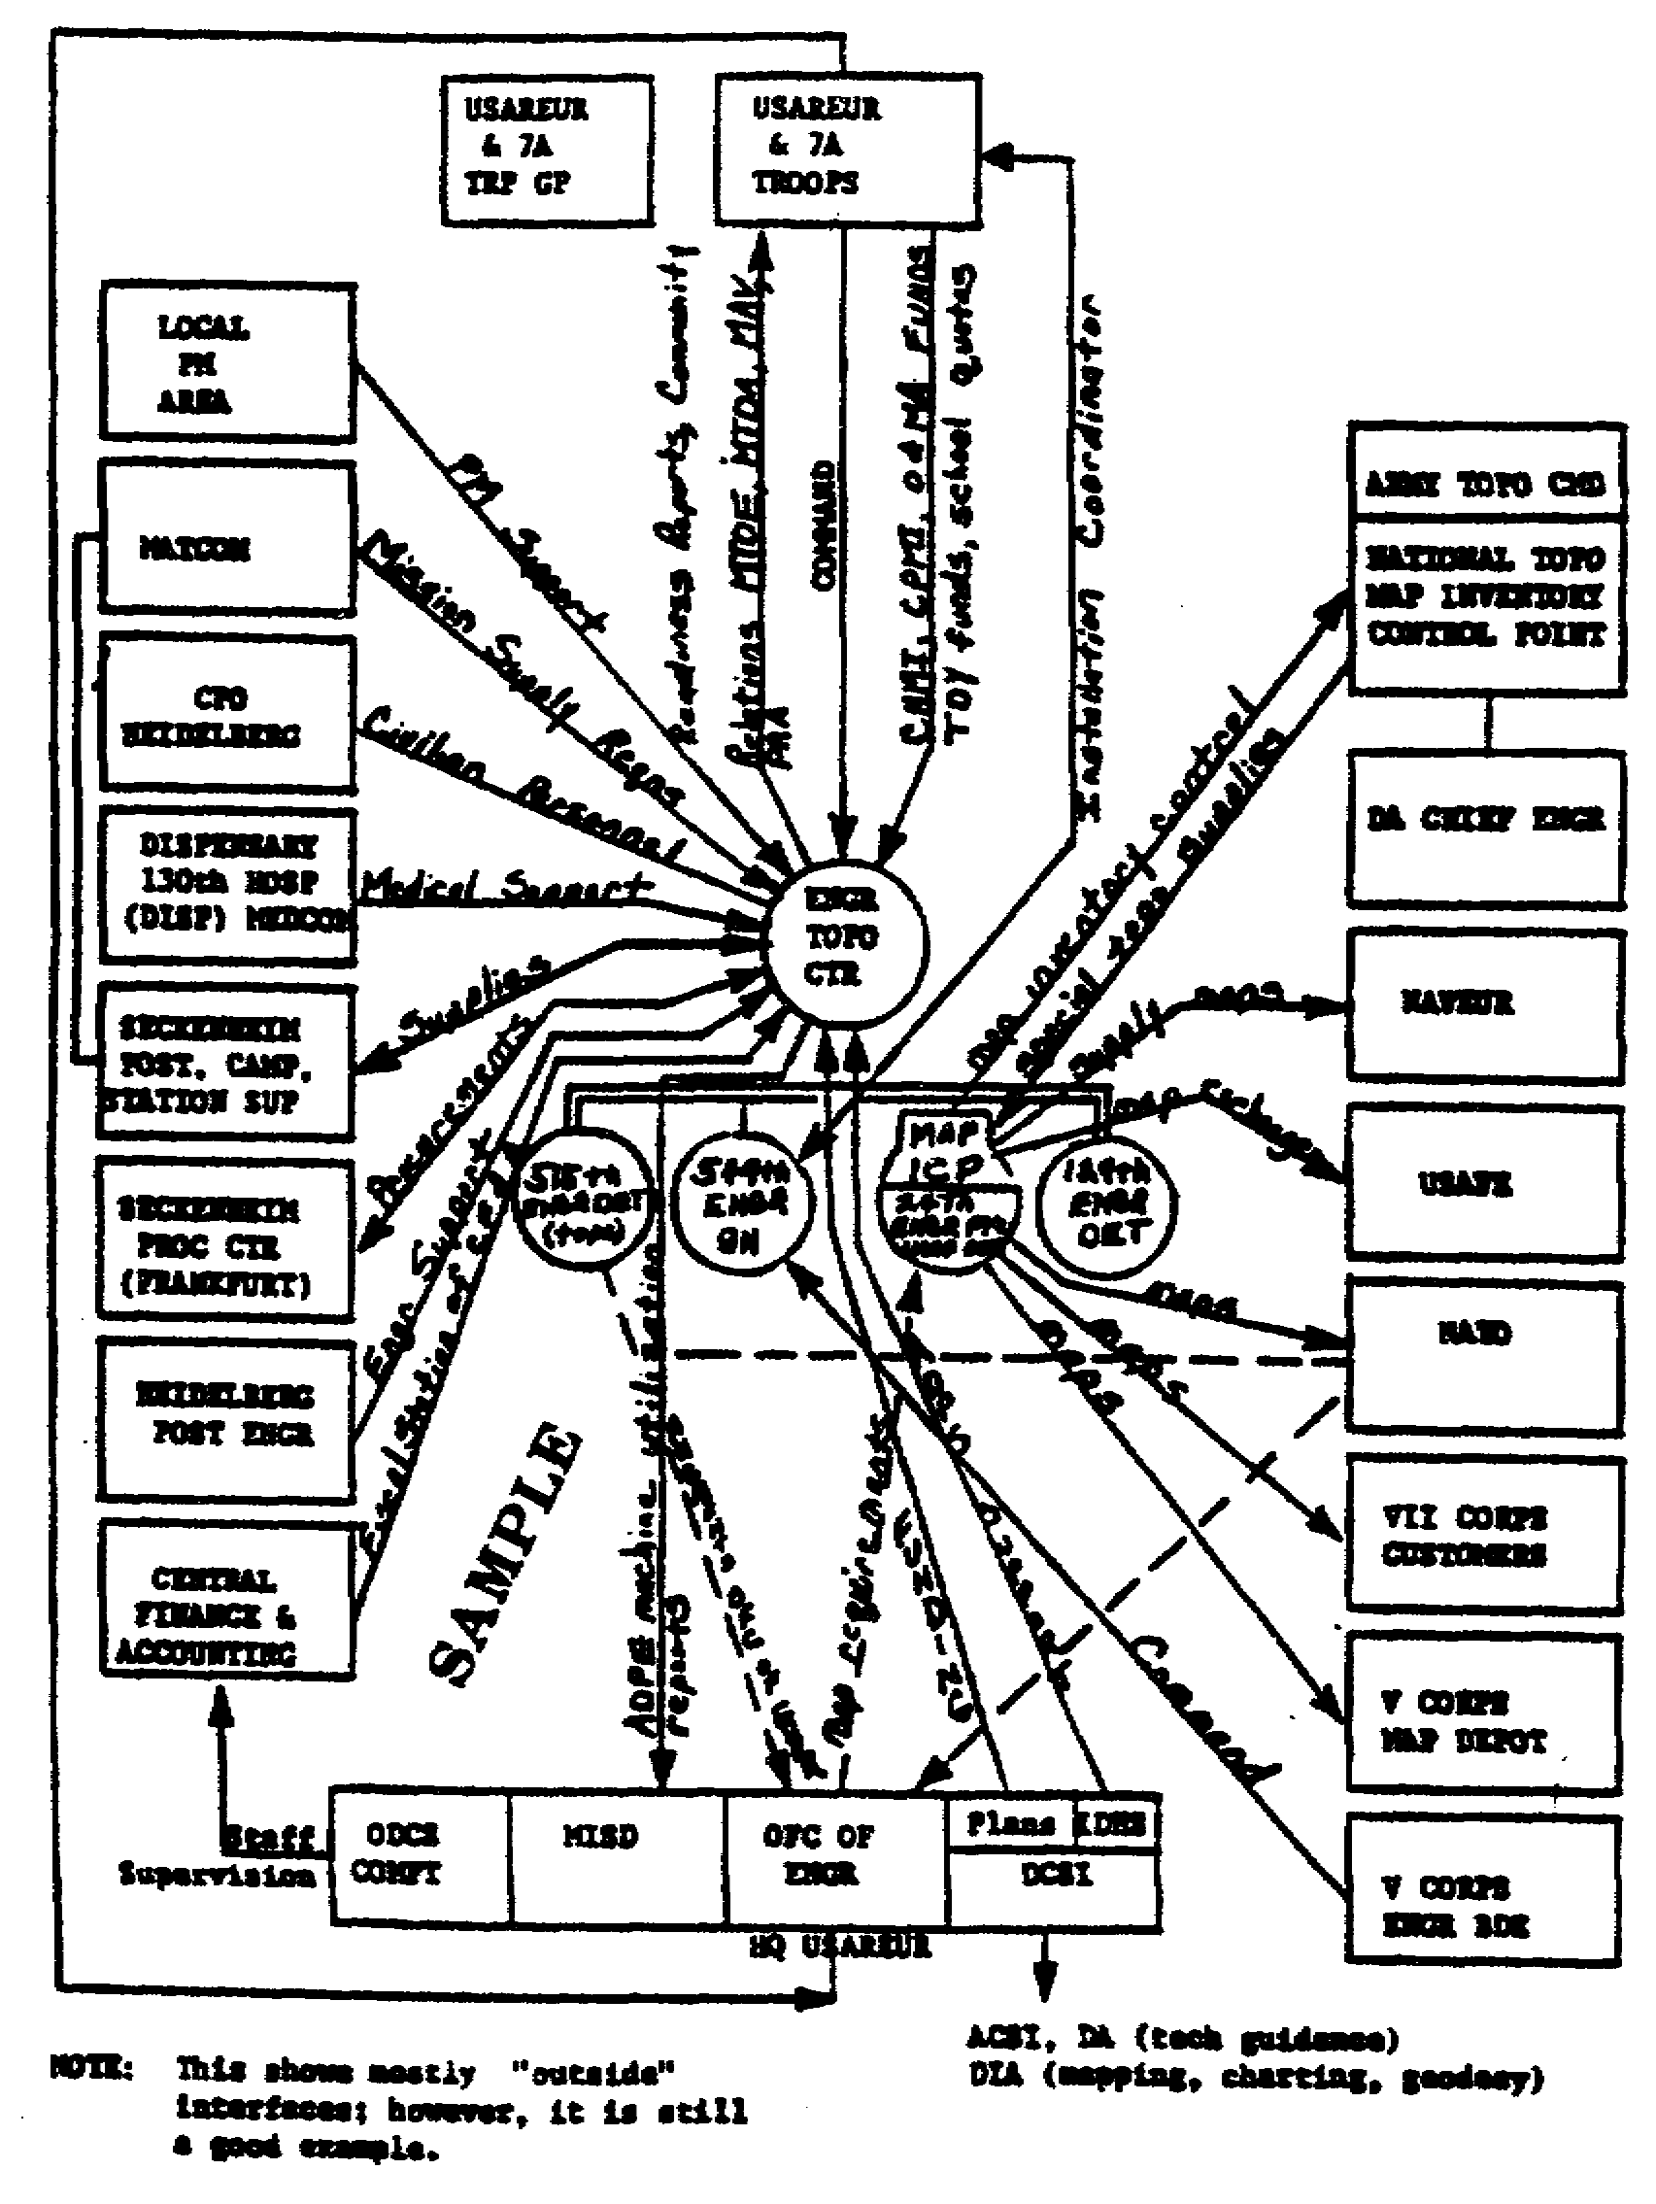
Figure 1-5. Functional Interface Chart.

18 FI 0950
SPECIAL PROCEDURES STEPS

Step 1. Screen out irrelevant functions to determine key command, and functional interfaces.

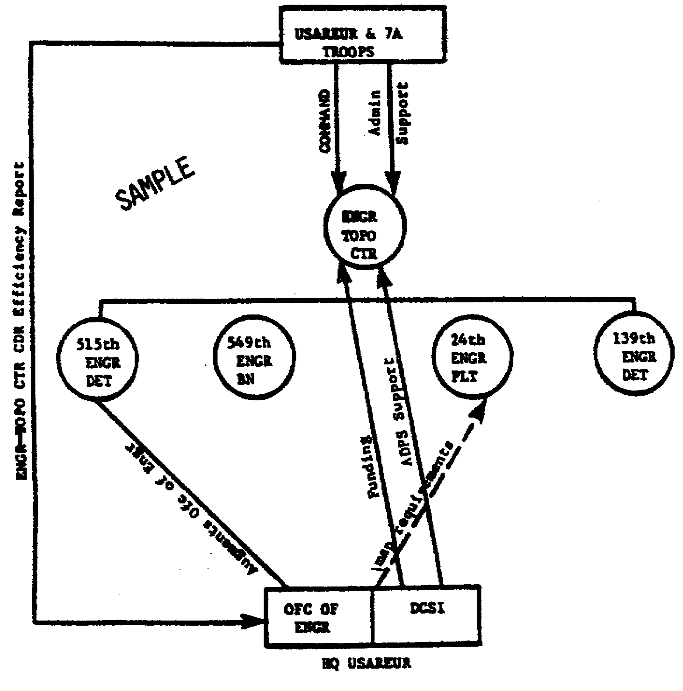
Figure 1-6. Special Procedures Steps.

Step 2. Analysis of key command, control, and functional interfaces indicates -

a. The 515th Engineer Detachment should not be under the Engineer Topo Center. It should be part of Office of Engineer.

b. If command or Engineer Topo Center were given to Headquarters United States Army Europe- (HQ USAREUR), then USAREUR & 7th Army troops would be dropped out and the command and control would be simplified.

19 FI 0950
c. Three questions must be answered in order to clarify the picture:

(1) Who really exercises operation control of Engineer Topo Center?

A. Office of Engineer.

B. Office of the Deputy Chief of Staff for Intelligence (DCSI).

(2) Where does the 139th Engineer Detachment fit in?

(3) What is the real relationship of the Engineer Topo Center Headquarters and the 549th Engineer Battalion?

Step 3.

a. Drop USAREUR & 7th Army Troops out of the sketch and combine 515th Engineer Detachment with the Office of Engineer.

b. Research 3 questions from Step 2.

Step 4. Show it:

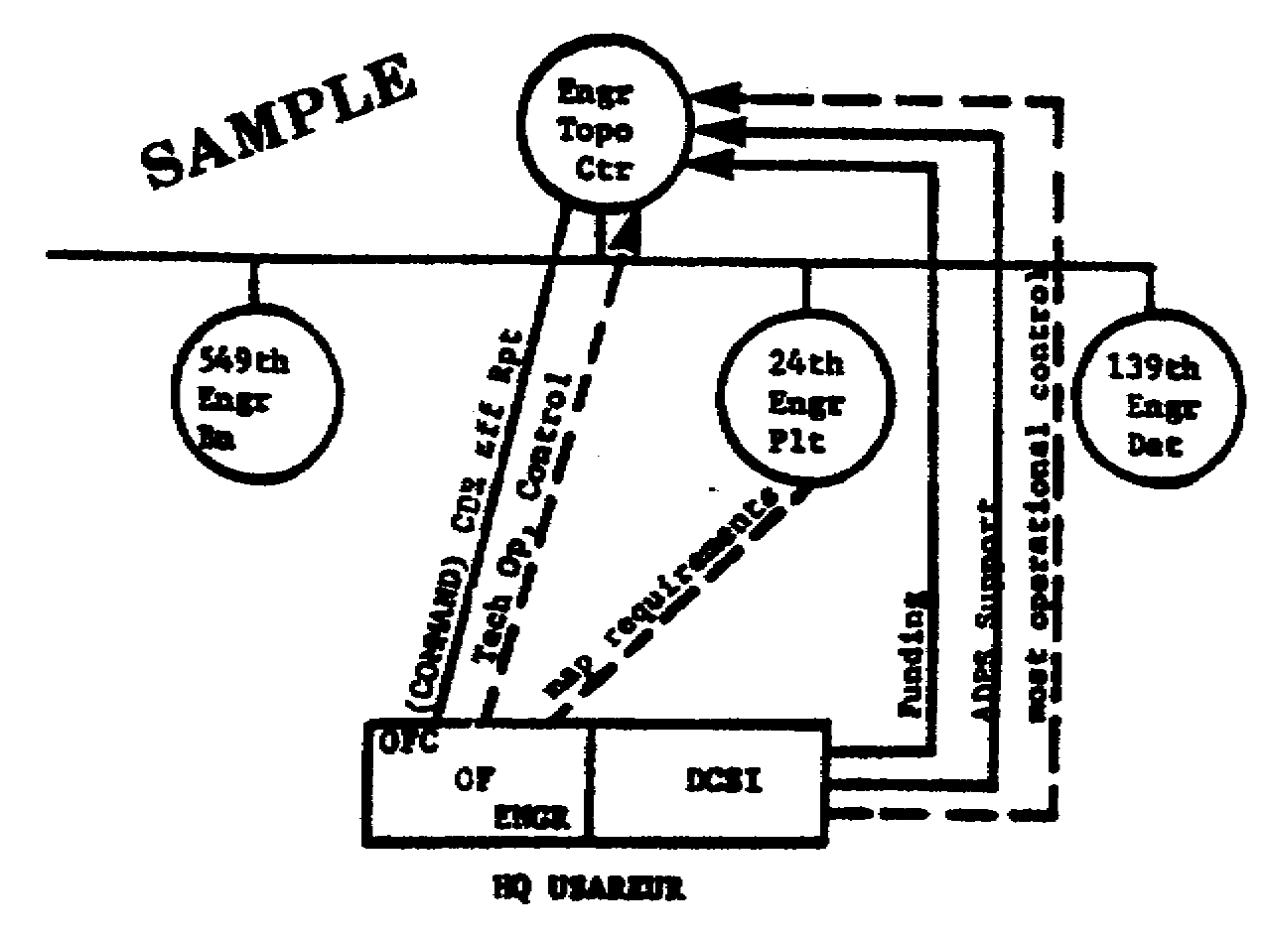
Figure 1-6. Continued.

20 FI 0950

Answers to the three questions:

a. DCSI exercises most of the control for operational matters. The Office of the Engineers exercises technical operation control for mapping.

b. 139th Engineer Detachment is a special utility outfit for HQ USAREUR. It could be transferred to Seckenheim or to USAREUR & 7th Army Troops (Headquarters Commandant (HQ COMDT)).

c. The commander of the Engineer Topo Center is also the commander of the 549th Engineer Battalion. The Engineer Topo Center Headquarters is really the Battalion Headquarters with a Tactical Director (TD) augmentation.

Step 5. Recommendations:

a. Command of the Engineer Topo Center should be exercised by the Office of Engineer, or DCSI (probably DCSI).

b. Move the 515th Engineer Detachment out of the Engineer Topo Center, and make it a part of the Office of Engineer TD.

c. Transfer the 139th Engineer Detachment to either the Seckenheim Support Activity, or to USAREUR & 7th Army Troops (probably USAREUR & 7th Army Troops).

d. Eliminate either the Engineer Topo Center HQ, or the 549th Engineer Battalion HQ. (Probably keep the Engineer Topo Center with the 549th Engineer Battalion HQ, serving as its nucleus.)

Step 5. Results;

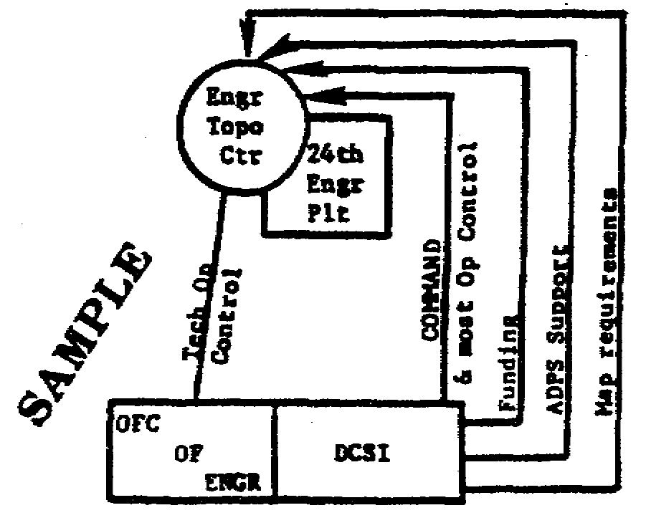
Figure 1-6. Continued.

21 FI 0950
(2) The Star. Figure 1-7 show the functions as they relate to each other. It also shows key personnel and how they fit into the picture. In this particular case, it is used to show that some key personnel are "split" several ways - into several functional areas - to the detriment of the organization. It also reveals how some functions are used as "buffers" between conflicting functions; i.e., Military - Strategic is used as a buffer to separate Political from Military - Tactical. It is a handy tool to portray visually what hundreds of words would fail to do.

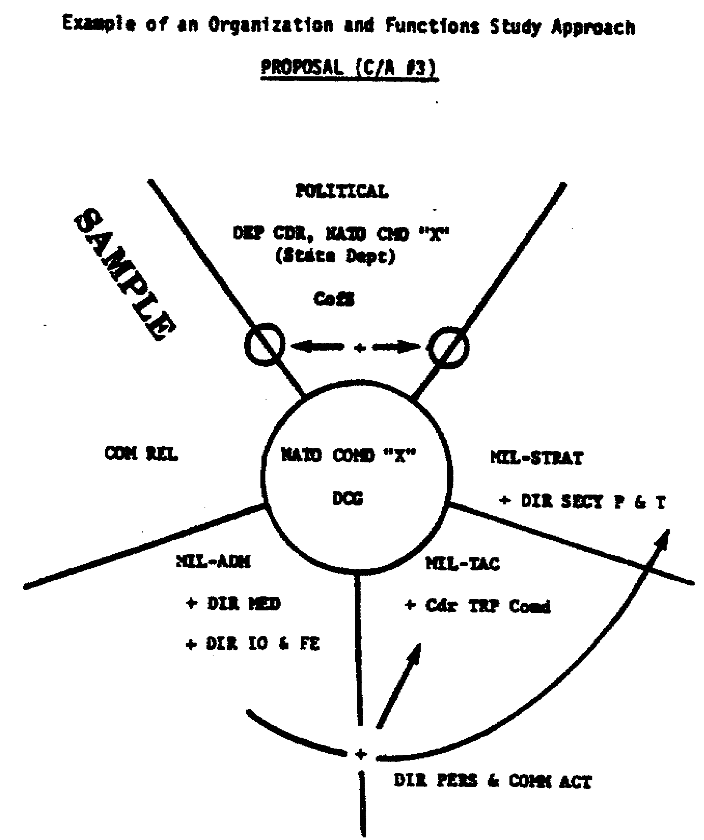

Figure 1-7. Organization and Functions Study Approach.

22 FI 0950

(3) The Milestone Chart. The milestone chart figure 1-8, is a common tool for analysis because it can be used to show phased implementation of proposed reorganizations. It also can be used in the initial memorandum to an organization showing your survey schedule.

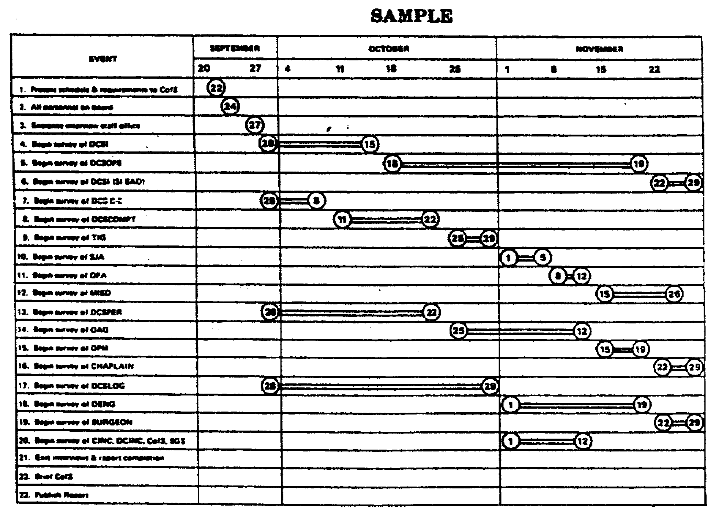

Figure 1-8. Milestone Chart.

23 FI 0950
(4) The Cross-Hatched Organization Chart. This technique of cross-hatching organizational "boxes" figure 1-9, is useful if you want to depict how a staff responds to the chain of command. The cross-hatching shows what proportion of the staff function is supervised by specific individuals. It is particularly effective when a key individual is faced with a span-of-control problem and you want to show how your proposal modifies or solves that problem.

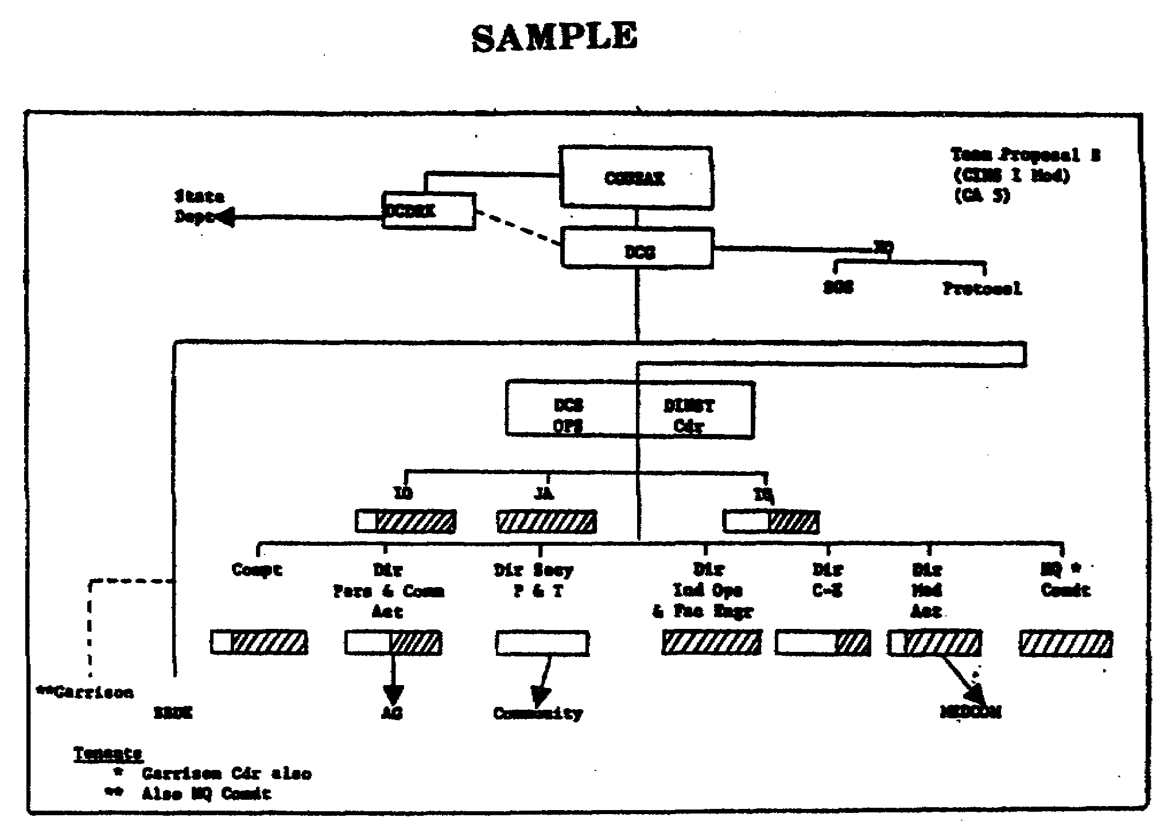

Figure 1-9. Cross-Hatched Organization Chart.

24 FI 0950
(5) The Finding. This is simply a format (figure 1-4) used to isolate each individual problem. You state what the problem is - FINDING. You discuss all relevant aspects - DISCUSSION. You then make a RECOMMENDATION. The value of this format lies in the fact that you must isolate and specify each problem. You then discuss it, and make a recommendation. It is a rule that merely isolating and identifying a problem is not enough; you also must propose a solution. When you force yourself to use this format, you will find that you very seldom are left without a solution or recommendation. This format forces you to think until you can make a sensible recommendation. In your management survey recommendation, do not "Recommend that another survey be conducted of this area." There may be rare cases in which this must be done, but, whenever you are tempted to make this recommendation, take another look at your findings. You may find that you will propose a solution to the problem.

(6) Ratios. Ratios are a handy tool to check the:

(a) Proportion of supervisors to workers.

(b) Proportion of administrative personnel to workers.

(c) Proportion of supervisors and/or administrative personnel to workers by comparable organizational units (staff offices, staff divisions, or branches).

(d) Proportion of selected grade personnel to other groups (number of colonels versus all officers, field grade versus company grade, or GM-13, 14, 15 to all GS grades).

(e) Proportion of time spent on administrative versus operational matters.

(f) Proportion of time spent on nonproductive matters versus productive time.

(g) Comparison of these time ratios between similar or identical operations or units.

(h) Proportion of routine to one-time actions.

Note: For a discussion of ratios see figure 1-10.

25 FI 0950
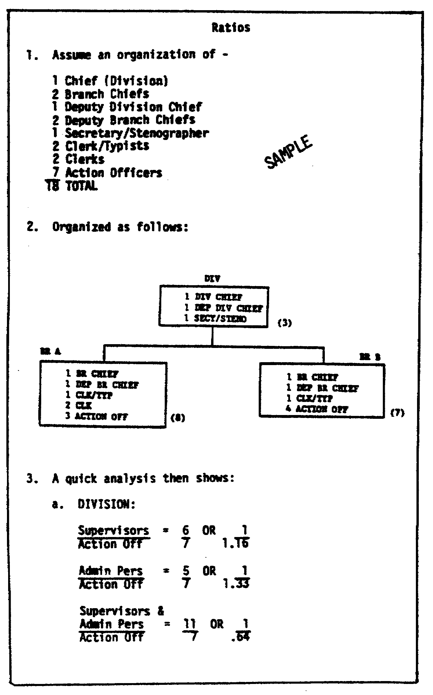
Figure 1-10. Ratios.

26 FI 0950
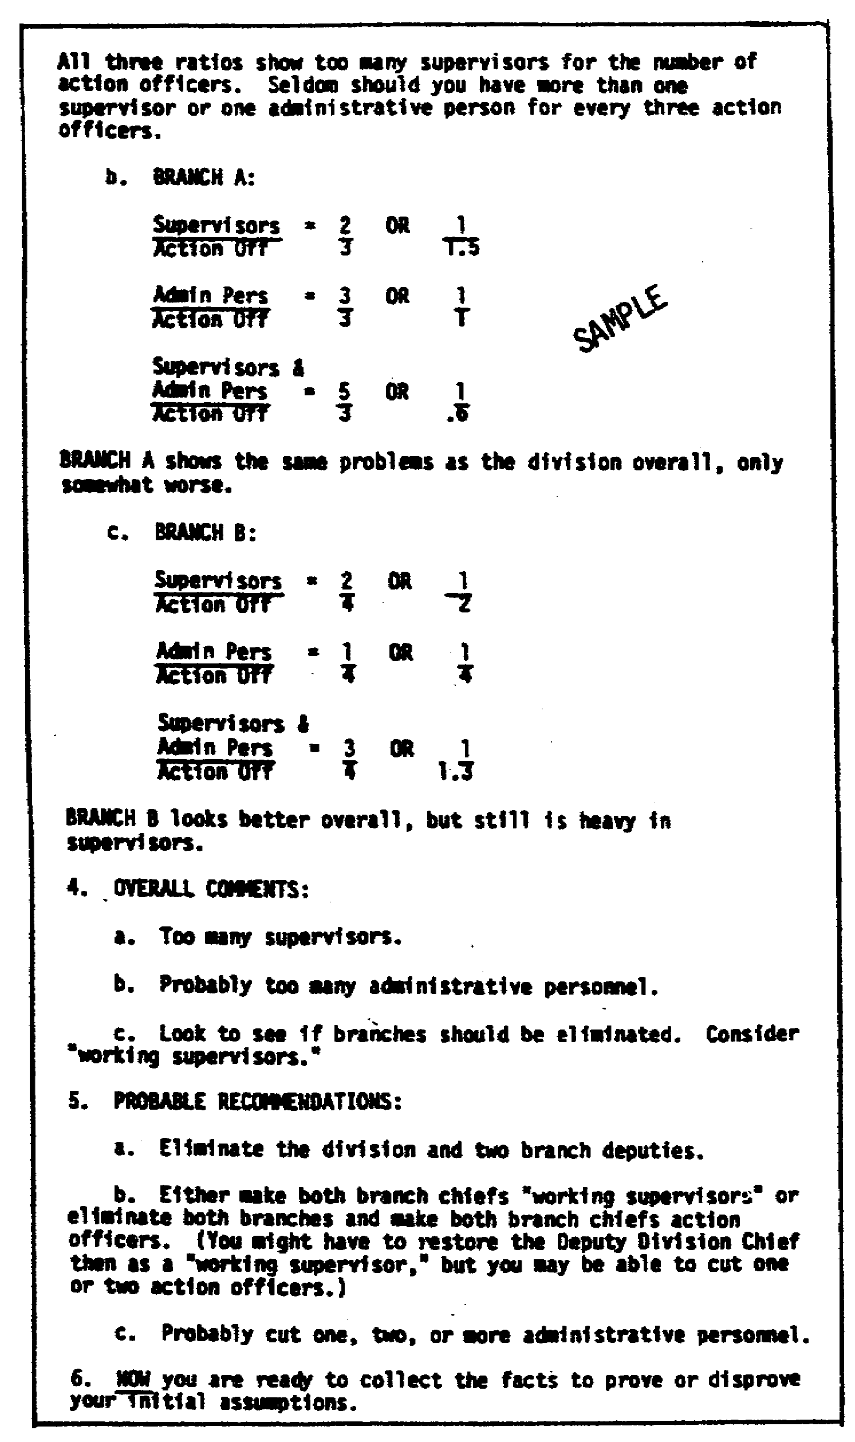
Figure 1-10. Continued

27 FI 0950
Ratios are a "quick" way to check suspected problem areas. For example, if you find a ratio of 1.5 supervisors to 1.0 worker, you immediately are aware of a potential oversupervision problem or of an understaffed worker problem. Do not accept this as truth, because numbers are often misleading; but it does give you some leads on areas that should be examined. Ratios also can be used to back up your findings for your briefings and your written reports.

(7) Spread Sheets. These sheets (figure 1-11) come in all sizes, shapes, and descriptions. Everyone uses them. Use them as worksheets to compile data or to show summary data. Usually they are not standard; therefore, you normally must develop your own. Once in a while you can get lucky and use one that you or people in the surveyed organization have previously developed. They are valuable for compiling data and showing summary data for briefings and written reports.

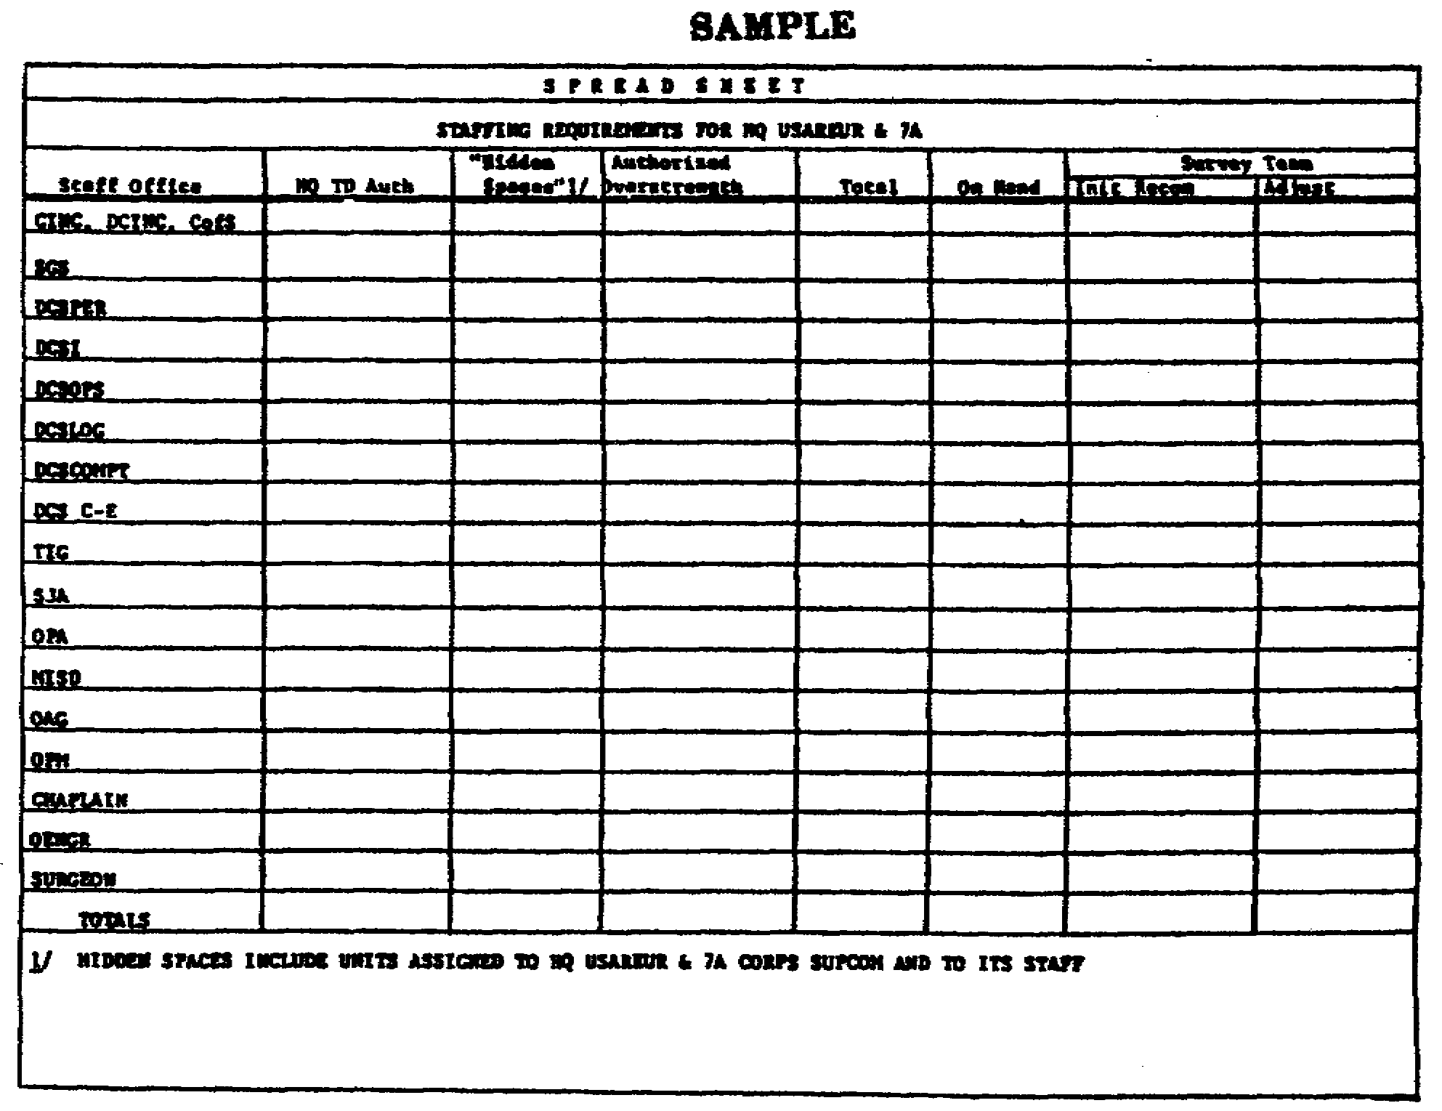

Figure 1-11. Spread Sheet.

28 FI 0950
(8) Logic Charts. Such a chart (figure 1-12) is a handy gadget that permits you to deduce logical answers if certain conditions or assumptions are true. It should be designed so that you can wade through a mass of data, detect problems, and produce possible solutions. It is a thought provoker. It also forces (or permits) you to attack problems that you do not really understand. When logic charts work, they help you with your analyses and give you a chain of logical facts and assumptions to use in briefings and written reports, and in showing how you reached certain conclusions and solutions.

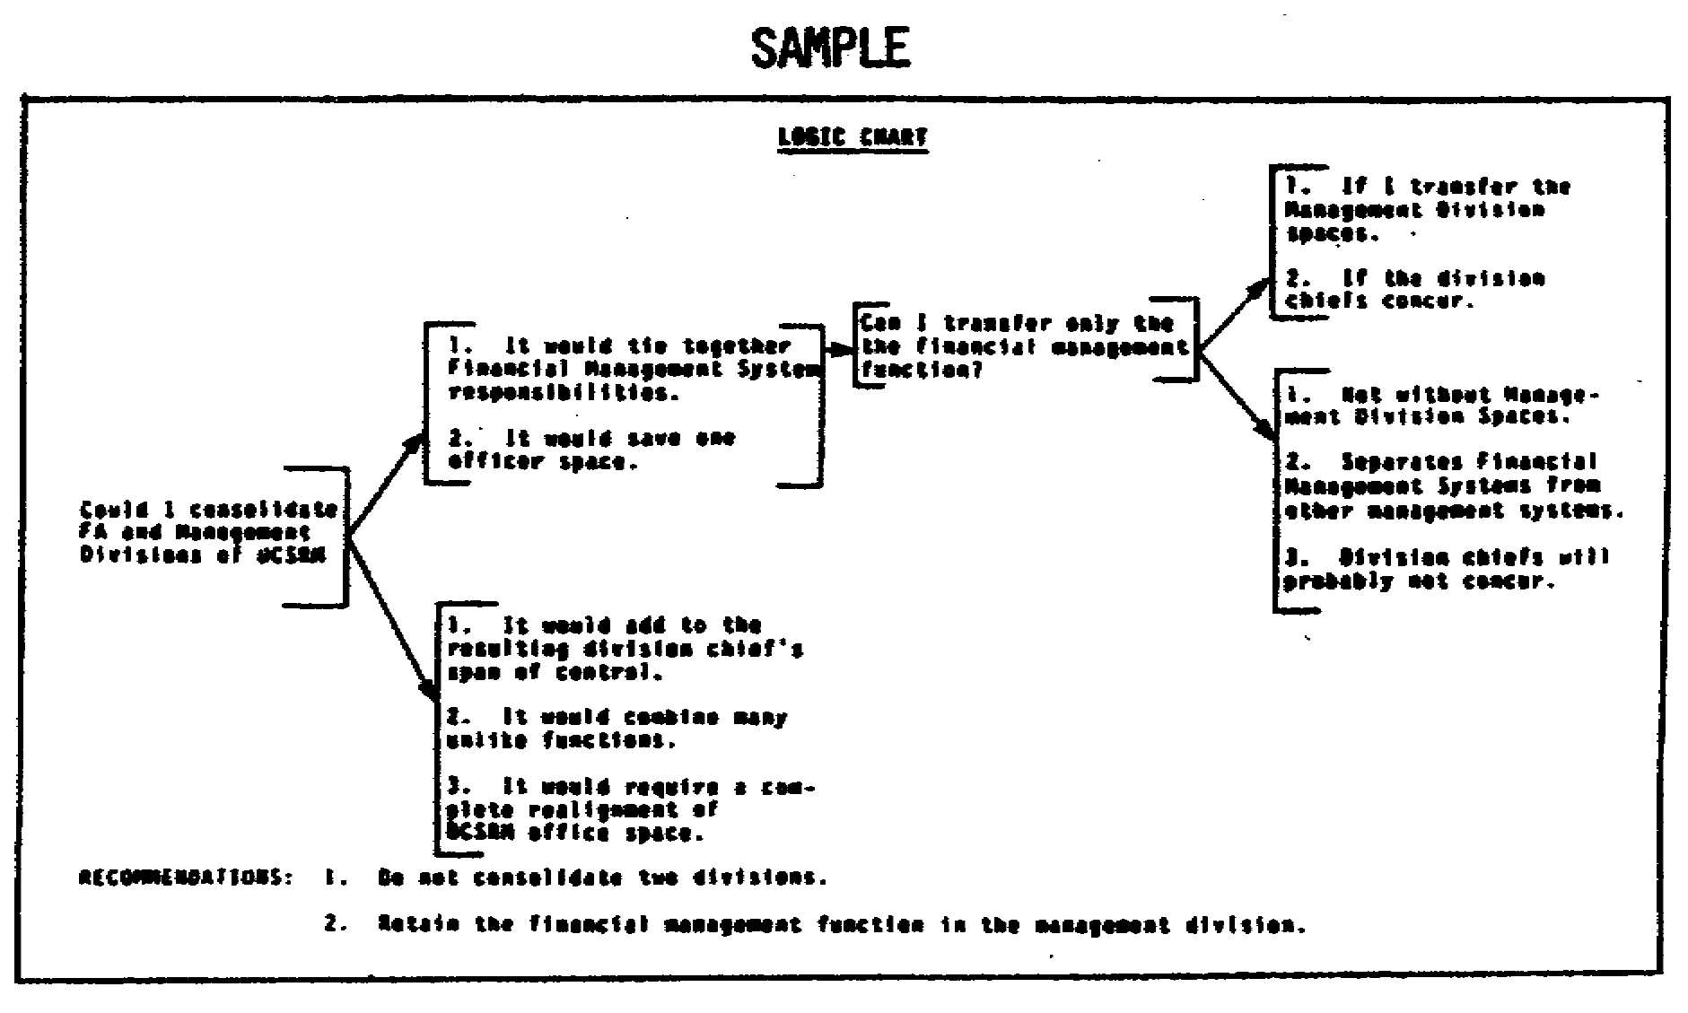

Figure 1-12. Logic Chart.

29 FI 0950
(9) Logic Tables. A logic table is really a series of questions, with predicted results, if certain answers are assumed. In figure 1-13, notice the questions, answers and conclusions.

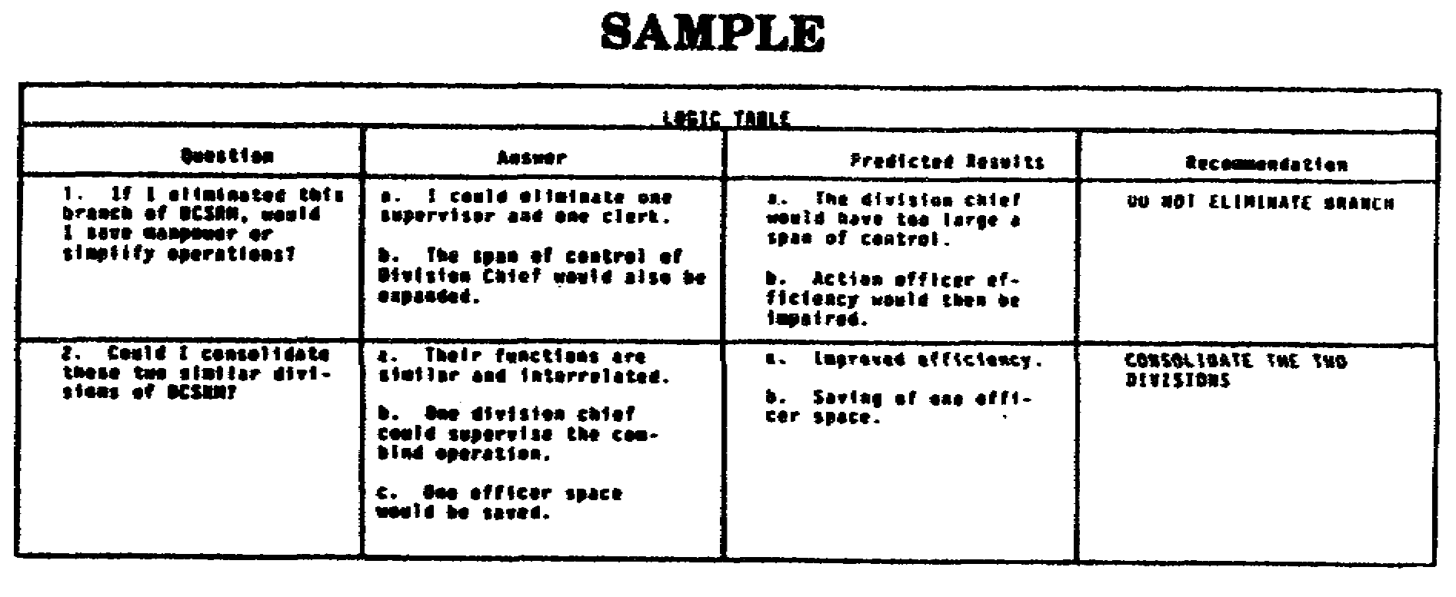

Figure 1-13. Logic Table.

30 FI 0950
PART C - COMBINING MANAGEMENT AND MANPOWER SURVEYS

1. To combine the management and manpower surveys, you must start with the proper concept. The proper concept is your method of approach. Here are a few approaches:

a. Combine the two as one survey and use integrated management and manpower teams. The steps to do this are as follows:

Step 1. Identify missions, functions, and procedures - both legitimate and illegitimate.

Step 2. Reorganize or modify (on paper) the surveyed organization.

Step 3. Have the manpower surveyors then staff the people, usually on a 'position' or man-hour workload basis, to do the job.

b. Conduct the management survey first. Then immediately send in a separate manpower team to staff the organization.

c. Conduct the management survey first. After 3 to 6 months - enough time for the organization to compile workload data - conduct a separate manpower survey.

2. For an integrated survey, your ratio of management analysts to manpower surveyors should be 1 to 1 or 1 to 2. It normally takes a few more people to conduct the manpower portion of a survey.

a. You are normally better off if the integrated management and manpower survey is headed by a management expert.

b. A typical integrated management and manpower survey team could look like figure 1-14.

31 FI 0950

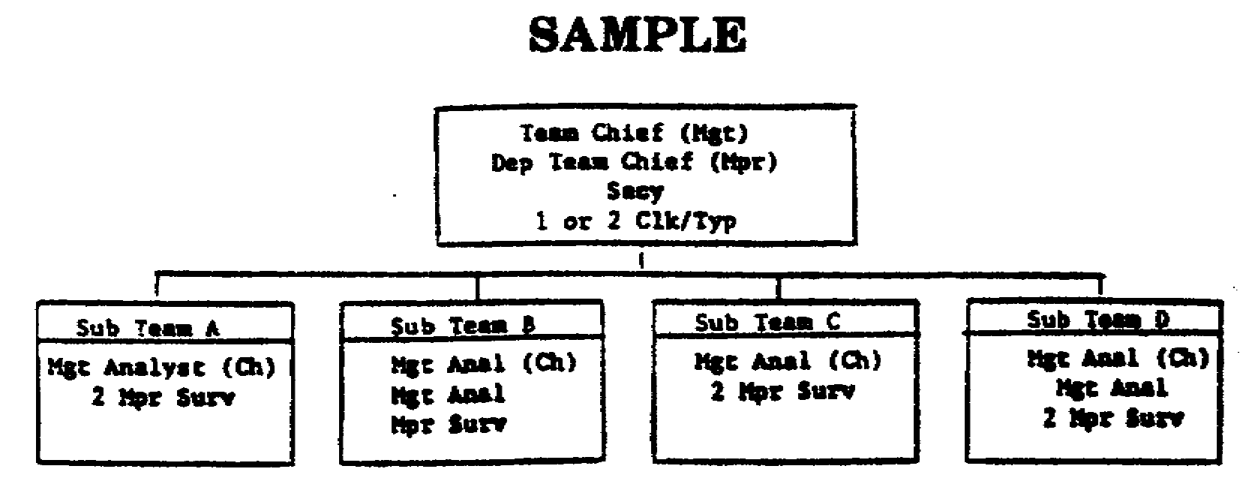

Figure 1-14. Integrated Survey Team.

d. The integrated management and manpower survey approach is preferable when you want to do the complete job in the shortest possible time. It also permits both the management analysts and the manpower surveyors to have the benefit of the reasoning behind organization changes, and the manpower required to operate the changed organization.

e. The advantage of delaying the manpower survey for 3 to 6 months after the management survey is that the actual manpower workload data under the new organization can be compiled before the manpower survey.

f. Having the manpower survey immediately follow the management survey is the least preferred of the three approaches. It has the advantage of neither the integrated survey nor the delayed manpower survey. Further, it permits the two teams to conflict in their approaches to the surveyed organization.

PART D - CLOSEOUT PROCEDURES AND BRIEFINGS

1. Closeout Procedures.

a. Start your closeouts. You can closeout with supervisors down to whatever level you desire. Time, controversy, and other factors will determine with who you close out. Examine a few degrees of closeouts in figure 1-15.

32 FI 0950

b. Middle-of-the-Road Closeouts. Restrict it to division chiefs and above, as shown in a above.

c. Hail to the Chief. Restrict it to the commander and whomever he selects from-the command group.

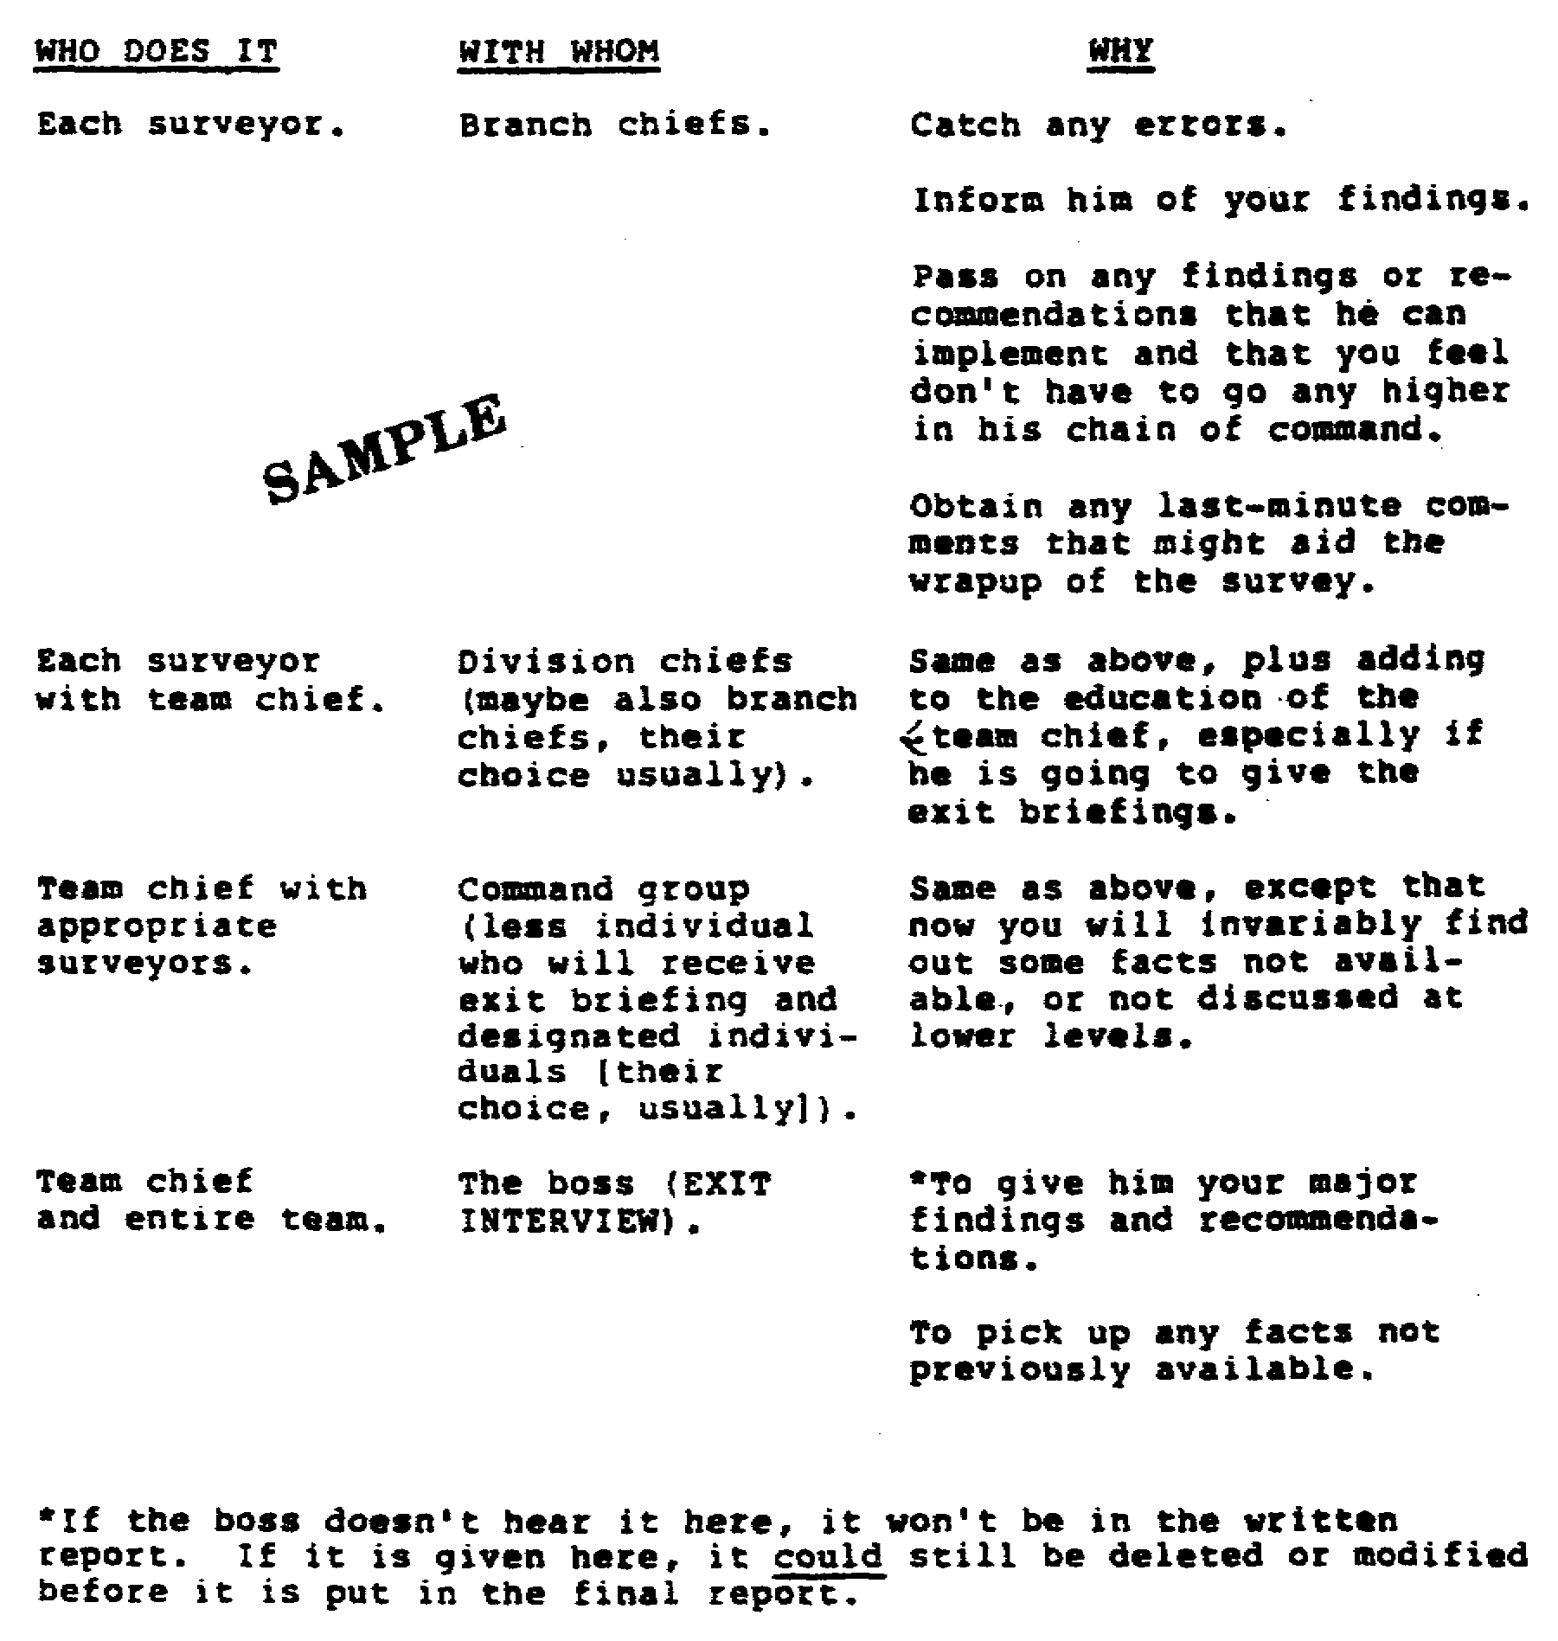

Figure 1-15. Closeout Procedures.

33 FI 0950

2. Briefings at Closeouts.

a. At branch level (each surveyor).

(1) Everything that is pertinent.

(2) Positive/Negative aspects of the operations.

(3) Things that are only for him and things that will go up the chain of command.

(4) Anything that will be discussed at higher level closeouts.

(5) This briefing is usually very informal. Charts are seldom used. Make it more of a discussion than a briefing. There is usually a lot of 'give and take" at this level closeout.

b. At division level usually each surveyor and team chief with the surveyor conducting the closeout.

(1) Same comments as in a paragraph 2.

(2) Normally, this is the first time that you use charts. You will find that some charts will require minor or major changes before the command group briefings.

(3) Discuss only those things briefed at branch level, unless new issues have occurred since that briefing. If new issues have occurred, make sure that the branch chief knows about them before the division briefing.

c. At the command group level the team chief with surveyors, normally.

(1) Use the charts, remembering the points mentioned above, or conduct an informal discussion. It depends on the preference of the team chief and the command group which way you go. The informal briefing approach, using the charts, is usually preferred.

(2) Sometimes the briefing of the command group are held together. Leave that up to the command being surveyed unless time constraint requirements force you to combined briefings.

34 FI 0950
d. At the commander's level (team chief with all of the surveyors). Emphasize to the commander that your written report cannot be completed and given to him until after his briefing. This lets him know that you are still considering any comments that he may make and that you are not 'locked in' on findings and recommendations. You should not be "locked in' even at this stage. Too many things can still be brought up by the boss that may change your report.

PART E - PREPARATION OF THE WRITTEN REPORT

1. The Formal Report. The survey report includes the findings, conclusions, and recommendations of the survey team.

a. Characteristics of a good report. Every good report has at least five outstanding characteristics. They are:

(1) Completeness with brevity.

(2) Accurate statement of facts.

(3) Interest.

(4) Good appearance and uniform arrangement.

(5) Use of proper English with words and sentences that are well chosen and well formed.

b. Contents of the Written Report. The written report is composed of a series of standard sections that can be telescoped or expanded depending on the complexity and type of project involved. These various parts are separately listed and described below. (Appendix A shows an example of a completed survey report.)

(1) The title page. A cover sheet that contains the title of the project, any identifying control numbers, date of review, and names of the team's members.

(2) Table of contents. Self explanatory.

(3) Purpose of the Survey. The original survey definition statement together with subsequent modifications, who requested the survey, the functional areas and organizational elements involved, survey limitations, factors for maximization, and any assumptions that are necessary for problem analysis.

35 FI 0950

(4) Summary of recommendations. A brief statement of the conclusions and recommendation(s), ranked in order of importance and identifying the major benefits that will accrue to the organization as a result of approving the recommendations.

(5) Main body. A more detailed discussion of findings and conclusions including the facts and logic used in arriving at the summary recommendation(s). This section is primarily for detailed assimilation and consideration. It typically includes the economic considerations and the cost benefit impact of implementing the proposals, where these have been analyzed.

(6) Action program. Actions necessary to implement the proposal. In many survey reports there is a lack of understanding concerning who should take corrective action. The recommendations derived from the findings and conclusions must be clear statements of the action to be taken, by whom, and what the results should be.

(7) Credits. Sincere, but not flowery, expressions of appreciation for assistance during the project. Mention by name and position.

(8) Appendix and attachments. Detailed tables, charts, diagrams, layouts, etc., either supporting facts or documenting the proposals in the report proper.

2. Coordination and Transmittal. The final survey report, unless otherwise stated by the person who authorized the survey, is to be forwarded to that official only. Distribution of the survey report will be made by the authorizing official and survey team members will treat all information contained in the report as confidential. Confidentiality does not, however, preclude informal review of survey recommendations with intermediate level supervisors. Their concurrence with the recommendations is an essential ingredient for the overall success of the survey. However, their concurrence should be accomplished on an informal basis unless otherwise authorized. The final survey report should be forwarded with a brief transmittal letter that outlines the original objectives of the survey. Additional copies of the report should be provided as necessary for distribution by the commander.

36 FI 0950
LESSON

PRACTICE EXERCISE

Read and answer the items in this Practice Exercise. Check your answers with the answers that follow

1. The Army defines management analysis as a staff function undertaken to help the commander, his staff and supervisors in the chain of command to:

A. Gather, analyze, and recommend various technical solutions to scientific problems.
B. Find and install better, faster, or cheaper ways to carry out the mission.
C. Solve management personnel hiring and placement problems.
D. Prepare and conduct manpower surveys biannually.

2. If a management survey is requested, the requester usually specifies:

A. The time available.
B. The team size.
C. The team composition.
D. What he wants to have the team look at.

3. When conducting interviews it is a good idea to

A. interview workers in key positions as well as "known unofficial leaders," if possible.
B. interview the supervisor only.
C. interview functional area chiefs.
D. interview select personnel from the major headquarters.

4. In preparation for a management survey you should

A. create a milestone schedule, have a team meeting, and get a copy of the organization's mission statement.
B. create a milestone schedule, establish a point of contact, and have a team meeting.
C. establish a point of contact, get a copy of the organization's mission statement and request pertinent surveys.
D. create a milestone schedule, establish a point of contact, and get a copy of the organization's mission statement.

37 FI 0950

5. During team entrance briefing, team support requirements should

A. be detailed if not previously coordinated with the surveyed organization point of contact.
B. not be addressed.
C. be realigned to match functional area requirements.
D. be part of the closing brief.

6. What are the two basic sources of information used by the analyst during management surveys?

A. Ledgers and charts.
B. Statistics and models.
C. Existing documents and personnel.
D. Existing records and questionnaires.

7. During a management survey, which of the following is not a source of information?

A. Existing records.
B. Questionnaires.
C. Personal interviews.
D. Field manuals.

8. Work sampling is an example of what method of information gathering?

A. Statistical method.
B. Questionnaires method.
C. Study of existing records method.
D. Personal interview method.

9. When combining management and manpower surveys to complete the job in the shortest possible time, the preferred approach is to

A. have the manpower survey immediately following the management survey.
B. conduct an integrated management and manpower survey.
C. conduct the management survey first, then conduct the manpower survey 8 to 10 months later.
D. have the management survey conducted by the manpower surveys team.

10. When preparing the final written report for a management survey, the report should not contain:

A. extensive detailed information on all levels of the organization.
B. a purpose statement.
C. credits.
D. recommendations.

38 FI 0950
LESSON

PRACTICE EXERCISE
ANSWER KEY AND FEEDBACK

Compare your answers to the following solutions. If you answered any item incorrectly, review the page(s) and paragraph(s) referenced until you understand the instructions.

Item Correct Answer and Feedback

1. B. Find and install better, faster, or cheaper ways to carry out the mission.

The Army defines management analysis as a staff function undertaken to help a commander, his staff, and supervisors in the chain of command find and install better, faster, or cheaper ways to carry out the mission. (page 1, para 2)

2. D. What he wants to have the team look at.

When a survey is requested, the requestor usually specifies what he want the team to do or look at. (page 2, para 2)

3. A. Interview workers in key positions as well as "known unofficial leaders," if possible.

Get a feel for not only who the designated key people are but also where the real power lies (formal versus the always-present informal organization). (page 11, para 3b(7))

4. D. create a milestone schedule, establish a point of contact, and get a copy of the organization's mission statement.

(page 3, para 1b, and page 7, para 1g)

5. A. be detailed if not previously coordinated with the surveyed organization's point of contact.

The survey is initiated with a "team entrance briefing." Survey techniques can be discussed. Requirements for team support (if not previously covered with the point of contact) should be detailed. (page 10, para 2)

39 FI 0950
Item Correct Answer and Feedback

6. C. Existing documents and personnel.

There are two basic sources of information: existing documents and personnel. (page 12, para 1d(3))

7. D. Field manuals.

Field manuals are official doctrinal publications that govern military operations and training. They are beyond the scope of what we are dealing with in the management survey. (page 12, para 3.d.(3)).

8. A. Statistical method.

While the use of statistics is primarily considered as an analysis technique, statistical sampling techniques also have wide application in the fact-finding phase of the management survey. (page 15, para 1j)

9. B. conduct an integrated management and manpower survey.

Combine the two as one survey and use integrated management and manpower teams. (page 31, para 1a, and page 32, para 2d)

10. A. extensive, detailed information on all levels of the organization.

The survey report includes the findings, conclusions, and recommendations of the survey team, as well as a purpose statement, credits, etc., but it should also be marked by brevity. Extensive detailed background information should not, be included. (page 35, and 36. PART E.)

40 FI 0950

